2016/17

Explorations in Electronic Engineering

Ace Training Networks Project

Callum Owen-Bridge 15002504 (Team Leader)

Keiran Brown 15000194 (Scribe)

Andrew Campbell 15008029

Karl McCallion 15009882

Karl Myers 15008411(Chair Person)

The Engineers

The Engineers

**Plagiarism Statement**

I confirm that this assignment is my own work, no part of it has copied from any other person's work (published or unpublished), and any text that has been paraphrased has been cited in the body of the document with the full details of the original work included in the reference list.

I also confirm that I have read the guidance provided at:

http://www.hope.ac.uk/gateway/supportandwellbeing/studentadministration/understandingyourdegree/

I also confirm that I understand the consequences of academic misconduct and that it may result in termination of my studies at Liverpool Hope University.

|  |  |  |
| --- | --- | --- |
| Name | Sign | Date |
| Karl Myers |  | 09/11/2016 |
| Karl McCallion |  | 09/11/2016 |
| Callum Owen-Bridge |  | 09/11/2016 |
| Andrew Campbell |  | 09/11/2016 |
| Keiran Brown |  | 09/11/2016 |

Contents

1.0 Executive Summary 1

1.1 Requirements 1

1.1.1 Hardware 1

1.1.2 Software 1

1.13 Security 1

1.2 Response 1

1.2.1 Hardware 1

1.2.2 Network Technology 1

1.2.3 Software 2

1.2.4 Physical Security 2

1.3 Benefits 2

1.3.1 Hardware 2

1.3.2 Software 2

2.0 Background 3

2.1 Business Background 3

2.2 Problems 3

3 Requirements 3

3.1 Functional Requirements 3

3.1.1 Functional Hardware Requirements 3

3.1.2 Functional Software Requirements 4

3.2 Non-functional Requirements 4

3.2.1 Non-Functional Hardware Requirements 4

3.2.2 Non-Functional Software Requirements 4

4.0 Recommended Solution 5

4.1 Network Technology 5

Network Topology. 5

Hardware required for the network 8

Network Management 10

ISP for Internet Connection 10

Network Technology Redundancy 10

4.2 Hardware Required 11

Client PC Hardware 11

Server Hardware 13

Network Hardware 13

4.2.4 Other Hardware 14

Software Proposed 14

4.3.1 Operating Systems 14

Accounting software 15

Technical details 16

Customer Relationship Management (CRM) System 17

Intranet/Extranet Options for Ace Training 20

4.3 Security Considerations 21

Physical Security 21

Technical Security 23

Installed Application Security 25

4.4 User Training 26

Software 26

4.5 Support Staff 27

4.8.1 IT Support Staff 27

4.7 Server Management 27

4.9 System Maintenance 27

Server Maintenance 27

PC Maintenance 28

4.8.3 CRM System Maintenance 28

4.8.4 Network Management 29

4.10 Benefits of the Solution 29

Hardware 29

Network Technology 30

5.0 Total Costs 31

5.1 Networks Hardware 31

5.2 Server Hardware 31

5.3 Client PC Hardware 31

5.4 Other Hardware 31

5.5 Software 32

5.6 Security 32

5.6.1 Physical Security 32

5.6.2 Technical Security 32

5.6.2 Grand Total 32

6.0 Installation Schedule 33

6.1 Network Hardware 33

6.2 Client PCs 33

6.3 Server 33

6.4 Software 33

6.5 Physical Security 33

7.0 Training Plan 33

8.0 References 34

9.0 Appendix 37

9.1 Appendix A Hardware 37

9.1.1 Client PC 37

9.1.2 Server 38

9.1.3 Network 39

9.1.4 Other Hardware 39

9.2 Appendix B Software 40

9.2.1 CRM Solution 40

9.2.2 CRM Alternative Solution 41

9.3 Appendix C Physical Security 42

9.3.1 Server/Switch Room 42

9.3.2 CCTV 45

9.3.3 Client PCs 47

9.3.4 Total Physical Security Cost and Installation Schedule 47

# Executive Summary

## Requirements

Ace Training requires many different new systems put into place. These various requirements are segmented into two parts.

### Hardware

First of all, a new set of client PCs is required. These PCs will need to fit the general requirements of office work. The Marketing Director requires an Apple Macintosh computer. Also, a Server will be necessary to host various items detailed later in this section; this will need to be powerful enough to support many connections and software that will run on it. As for connections, a new network will be necessary for the office, interconnecting all clients to the server and the internet. The topology of this network will need to fit physically within the office as well as to be able to take peak throughput from all clients and the server.

Also required is a printer which will replace the fax machine to bring this up to date, communication with the Training Centre will be dealt with in software.

### Software

For all new client PCs, an operating system will be required. The server will also need an operating system to be chosen. Both of these should be capable of running all software intended to run on each of those machines. Other software required is accounting software, which will run both on the client PCs and on the server, so that records can be stored in a database instead of on paper. A website will also be needed to access company resources off-site, as well as email within the company, dealing with communication, not only with the Training Centre but also with the entire company.

### 1.13 Security

It is also a requirement for ACE training to secure their hardware and client data. The security will need to be robust enough to protect against electronic or mechanical intrusion and, moreover, meet the requirements set by the Data Protection Act 1998.

## Response

This section, like the previous, can be split into the same two categories.

### Hardware

A new set of business PCs will be provided to all members of staff who require them to allow each worker to access all computing resources. A server with enough computing power and storage will be created on site in the Liverpool Building that will host all services including the website software, Extranet hosting and a database for storing various details including customer details. A new network will be built within the Liverpool Building allowing for connections to the server from every client PC via an Ethernet switch while a router will provide a link to the internet. Specific topology of the network is detailed later in this report. A large screen monitor will be put up in the sales room, allowing sales staff to see how many sales they have made to motivate staff. This will be connected to the server via a small PC running software to obtain and display the data appropriately.

A printer designed to work in an office environment will be provided.

### Network Technology

A network will be implemented allowing for communication between departments. The network will be fast and efficient, increasing the sale process. The network will allow staff to access information much faster. An Internet service provided will be used for an internet connection.

### Software

Operating systems for both client PCs will be Microsoft Windows operating systems. The server can have many different operating systems. The two primary types being a Microsoft Windows based and a Linux based OS. Although, there are compatibility issues with Linux OSs. For instance, Sage Accounts software only supports Microsoft Windows-based operating systems. So the server operating system will be Microsoft Windows to combat any compatibility issues. By using the latest operating systems for each, security will be up to date and the latest features and services will be available. Up to date Sage 50 accounting software will be used. Email will be hosted by Microsoft’s “Outlook”, which can be done through Microsoft’s Office 365 software. This software will also include Microsoft Word, Excel and PowerPoint. CRM software will also be made by the company Sage, called "Sage Integrated CRM".

As for security software, Symantec’s Endpoint Protection will be used allowing protection of the Server and all Client PCs.

### Physical Security

To secure Ace Training hardware and data, a secure server room will be created. To do this, the store room will be split in two and the suspended ceiling will be replaced will be replaced with a solid framed ceiling, as to prevent intrusion from above. Also, a high security steel door fitted with a Codelock medium security electronic lock.

Furthermore, the server room will be fully insulated. Used in conjunction with an AC unit will facilitate temperature regulation and, thus, prevent overheating of the equipment.

All PC’s will be locked in place with PC locks and a CCTV system will be installed. The CCTV cameras will be will be installed at each entrance, in the server room and one camera will be installed externally to cover the rear entrance. The dedicated monitor and DVR will be installed within the secretary’s office.

## Benefits

As with the Requirements and the Response sections, this section will be broken into two sections, dealing with hardware and software independently.

### Hardware

By providing mid tower business level PCs, the company will have sufficient computing power for all modern business applications and network access. The server will provide adequate computing power by having in it the latest forms of hardware such as a Xeon E5 CPU and DDR4 RAM. These both offer future expandability by using some of the latest sockets in their motherboards allowing future CPU upgrades. Also, the server will be Blade form factor and will be stored in a cooled server rack within a server room allowing more servers to be used.

The network will be based on the Star topology, which is the most popular topology today allowing the use of multiport switches for maximum throughput over the Ethernet standard.

### Software

Microsoft operating systems have been chosen for both the client PCs and the server. For the client PCs, this offers a familiar operating system for the staff at Ace Training. For the Server, this offers compatibility for the various software that will be server based. By using an up to date Sage Accounting version, the staff will at least be partly familiar with the working of this brand of software without having to learn too much. Finally, by signing up for a domain with Outlook, email services will be already setup, and the domain can be the name of the company. Also, this is accessible even if the company server goes down, as this can be accessed via the Outlook website. Office 365 will provide a suite of Office applications, allowing for work to be completed easily. This software is easy to use and well known with plenty of support available should any queries arise. Sage Integrated CRM will offer excellent functionality and should be able to deliver all services that are required. This should also work well alongside the Sage Accounting software.

Symantec Endpoint protection will benefit Ace Training by implementing a firewall, antivirus and live protection whilst browsing the internet.

# Background

## Business Background

The company that we are creating a proposal for are called Ace Training Ltd. This is a small business which specialises in computer training courses in their centre and on customer premises. The issue this company are currently experiencing is slow sales performance due to old computers, outdated software, lack of communication between departments and no efficient way of storing customer details.

## Problems

The problems Ace Training Ltd are experiencing are as follows:

* All sale records are currently being recorded onto paper and client’s details are being stored in diaries, this has caused slow responses to sales and customers, therefore reducing sales and caused low morale in staff due to low commission rates.
* Due to all client details being recorded into diaries, other employees cannot access customer details.
* Currently, there is only faxing available for communication between the sales manager and training centre manager, which is not efficient.
* Only telephones are used to make sales, which can be slow and can reduce sales due to no call reminders.
* The computers and software are very outdated and limited reducing the efficiency of the company.
* Secretary is currently typing information into a computer to be stored on a tape drive, this is very time-consuming and can cause many errors.
* Promotions are not well targeted due to lack of accuracy; therefore, the company is not increasing in visibility or sales.
* The sales process is very slow due to outdated methods being used.
* The backup process is only made weekly onto a DAT tape drive; this needs to be increased
* More printer access is required.

# Requirements

This section details, broadly, the various parts of this project within the scope of functional, what the system must do, and non-functional requirements, how the system must perform the tasks. These items are broken down and detailed in the sections below.

## Functional Requirements

Here are listed the functional requirements of the system. These specify what the system must do in this scenario.

The first thing to consider when identifying functional requirements are the specified requirements of the solution that was requested by Ace Training themselves. Like the original specification, these can be broken down into hardware and software.

### 3.1.1 Functional Hardware Requirements

#### 3.1.1.1 Network

The network that Ace Training requests must be able to connect all computers within the office. The network must be able to uphold reliable communication links between all of the machines. The staff at Ace Training will need to be able to, amongst other things; Perform File Transfers, Access the Internet and Access a Server. Some other tasks may be necessary, but these are the main tasks concerning an office environment. So, the links between all machines must be fast enough to handle this information.

This system must also use network isolation to keep any secure traffic on communication lines that it is intended for.

#### 3.1.1.2 Client PCs

Ace Training requires new PCs installed at their centre. These PCs must be able to perform the tasks that are needed for the business. Some tasks involved are; Document Creation/Processing, Network and Internet Access and File Transfer. To perform these tasks, these PCs must have sufficient hardware to complete these tasks.

#### 3.1.1.3 Mac

The Managing Director of Ace Training requires a Mac Computer to do his work. This will have to perform more graphically intensive tasks such as Photoshop and Video Editing.

#### 3.1.1.4 Server

Much like the Client PCs, the Server must be able to complete various tasks; these include; serving many users at once, maintaining a database, keeping sensitive information secure. This comes down to the same requirements of the Client PCs; the Server must have the required hardware to perform these tasks.

### 3.1.2 Functional Software Requirements

#### 3.1.2.1 Accounting

The Accounting software used at Ace Training must be able to keep track of all financial information without delay or error.

#### 3.1.2.2 Customer Relationship Management (CRM)

This software must be able to keep track of a vast number of customer information. This information must also not be available to any users without proper authentication.

#### 3.1.2.3 Intranet/Extranet

This software must give users access to the database contained at Ace Training with proper authentication if required.

## Non-functional Requirements

### 3.2.1 Non-Functional Hardware Requirements

#### 3.2.1.1 Network

To perform how it needs to, the network at Ace Training must use a reliable topology with connections that can handle a sufficient data rate for Ace Training’s needs.

#### 3.2.1.2 Client PCs and Server

For the Client PCs and Server, the hardware must be powerful enough to handle the tasks that Ace Training will need them for. To perform these tasks, the hardware within them will need to be powerful enough. Also, these will need an appropriate network interface to allow network connections.

#### 3.2.1.3 Mac

This has the same requirements as the Client PCs, but will also need more graphical processing power and a more powerful central processor to handle the increased throughput of data.

### 3.2.2 Non-Functional Software Requirements

#### 3.2.2.1 Accounting

To keep track of all financial information for Ace Training, the accounting software will need to store various transactions within a database and perform calculations on this data.

#### 3.2.2.2 Customer Relationship Management (CRM)

This software will need to be able to store customer information in a database and allow access to it and modification as requested.

#### Intranet/Extranet

This will be hosted on the server and allow access to many users all at once.

# 4.0 Recommended Solution

## 4.1 Network Technology

In this section, the networking will be discussed, such as the topology, hardware required for the network, network management, recommended ISP and a conclusion of the network chosen.

### Network Topology.

Network topology is the arrangement of interconnecting devices. There are many ways to arrange these devices. A conclusion will be made to show which one will be recommended for Ace Training and the reasons for this decision.

#### 4.1.1.1 The Recommended Topology, Complex Star Topology

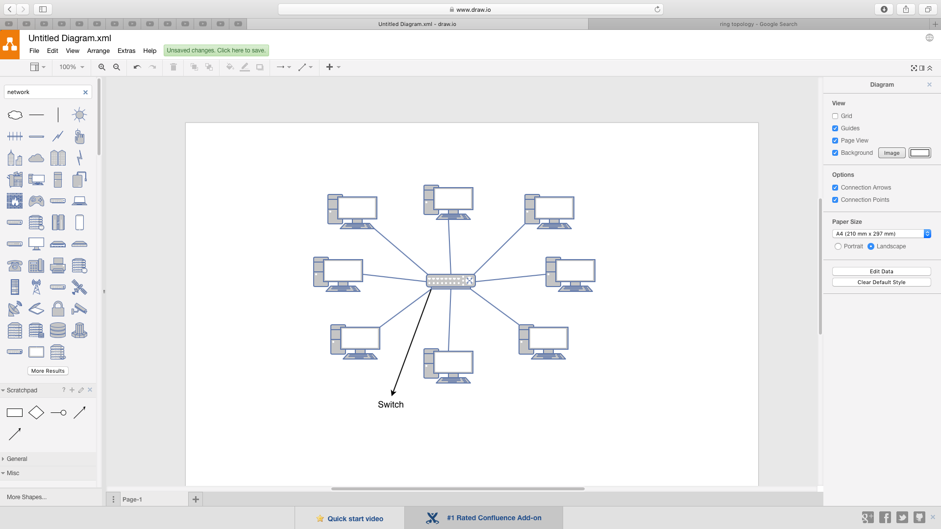

Figure – A Star Topology Layout

This contains a central node which is a switch. All stations connect to the central node, which is a star-like structure, as shown in figure 4. All transmissions are sent directly to the destination as the switch uses MAC addresses to send the data to the correct station.

Complex Star topologies can be formed by connecting multiple star networks together by the central nodes.

Issues

* More cable length is required as each station is connected to the switch individually, increasing costs.
* The single point of failure is the switch, because if this fails all the stations connected cannot communicate.
* The number of stations and the capacity needed can be limited by the switch used. The more stations required, the higher the cost.

Benefits

* If a station shuts down, all other stations can still communicate
* It is much easier to maintain this topology if it does not become complex.
* Transmissions from sources are only received by the destination and are not passed through other stations, as the switch changes the source to the correct channel or route of the destination.
* It is simple to connect or remove devices to the switch
* “Easy to diagnose network fault.” (Bisht and Singh, 2015)

#### 4.1.1.2 Recommended topology for Ace Training Ltd.

The network topology that is recommended for Ace Training Ltd is a complex star topology, which is multiple star networks connected. This topology has been chosen as it is the most efficient and cost effective compared to other methods; for example, sales traffic is separated from other traffic by connecting sales computers directly to the server switch and other departments are linked to the server switch through another switch, as shown in figure 6.

Figure6 the recommended network topology.

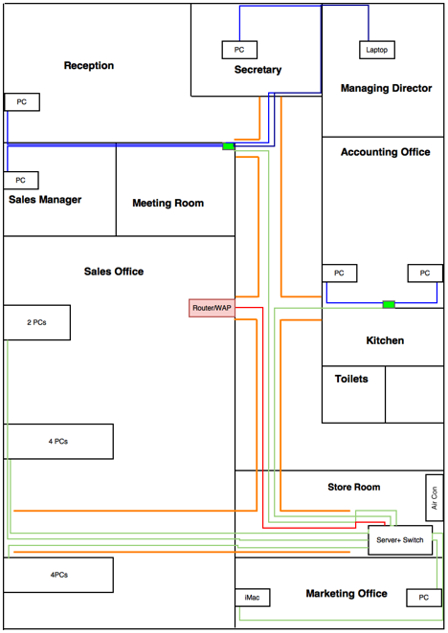

­­

In figure 6 the green lines represent connections to the server switch; red lines represent the router connection to the switch, and the blue lines represent connections to a separate switch. Reception, Secretary, managing director and Sales Manager are all connected to a switch by an Ethernet cable. Accounts are also connected to a separate, isolated, switch as their network traffic needs to be more secure, as they handle confidential information. The orange lines represent the cable trays. The trays will hold the cables above the suspended ceiling.

Using separate switches keeps the department’s network traffic distinct from others, “Centralization also allows the inspection of traffic through the network. This facilitates analysis of the traffic and detection of suspicious behaviour.” (n.d). This also reduces cost by reducing the amount of Ethernet cable needed as well as any interference between the Ethernet cables. The sales department computers will be connected individually to the server switch as well as the marketing department computers. The router will be connected to both the server and server switch by Ethernet cables; this will allow the computers to communicate still with the server if the server switch goes down. All cables and switches will be routed into the suspended ceiling to keep the cables out of view and protected, and this will also prevent tripping hazards. The server and server switch will be stored and segregated in the store room inside a secured server rack so that only authorised people can access the room.

The single point of failure of this network layout is the server switch and router as if these two devices fail there will be no communications available between the computers and server. The router is used to connect to the ISP, Internet Service Provider, which allows the LAN, Local Area Network, to connect to the internet and allows computers to communicate if a switch goes down.

Switches have better collision management than hubs, as they direct transmissions to the destination channel, this improves performance and full bandwidth use for each connection made.

The single point of failure of this network layout is the server switch and router as if these two devices fail there will be no communications available between the computers and server. The router is used to connect to the ISP, Internet Service Provider, which allows the LAN, Local Area Network, to connect to the internet and allows computers to communicate if a switch goes down.

This topology is recommended over ring topology because in a ring topology if a computer is removed in the network the network will go down as the circuit has been broken. Whereas, in a complex star topology, **“**Each device is inherently isolated by the link that connects it to the hub. This makes the isolation of individual devices straightforward.” Moreover, “This isolation also prevents any non-centralized failure from affecting the network.” (n.d)

In this topology, the transmissions are transmitted only to the destination, “compared to Bus topology it gives a far much better performance, signals do not necessarily get transmitted to all the workstations.” (n.d). In a bus topology, the “entire network shuts down if there is a break in the main cable”, (Singh1 and Verma2, n.d). However, in a complex star due to the multiple switches, other departments can still function. In a complex star network, devices can be added as more central nodes are added. However, in bus topology the transmissions speeds, “slow when more devices are added to the network.” (Singh1 and Verma2, n.d)

By using a complex star topology, the only bottleneck within the network is the central device used.

In a mesh topology, “a large number of I/O (input/output) ports are required.” (Singh1 and Verma2, n.d). This can increase costs and possible faults in the main device.

#### Redundancy

For redundancy, extra switches and medium can be bought. This will allow for faults to be fixed as soon as possible. The departments have been separated with switches, so if one of the smaller switches fails it does not affect other departments. This can also help find faults much faster. The router provides a wireless connection to the devices so if the wired local area network fails Ace Training can still run their business.

### Hardware required for the network

In this chapter, the hardware necessary for this network to be constructed will be discussed along with why they were chosen.

The components needed to form this network are:

* A router: to connect to the Internet via the ISP.
* Network Switches: to connect devices together so that they can communicate with each other.
* A medium: this is the connection between the devices.

#### Medium

In this section, the type of medium that will be used will be discussed, and a conclusion will be made.

#### Shielded twisted pair (STP)

This cable is like UTP however, each twisted pair is wrapped with a metallic foil, then all four twisted cables are then wrapped in metallic foil. This cable reduces interference within the cable and from external components; such as radio waves.

Due to the cable’s shielding methods, this is more expensive. There are also extra installation costs involved as the shielding must be grounded. If the shielding is not grounded “the shield acts as an antenna and picks up unwanted signals.” (Systems, Inc, and Systems, 2002). The data speeds of a Category 5 STP is up to 100Mbps and max cable length is 100m.

#### Medium Solution

The type of medium that is going to be used for the network is Category 6 shielded Ethernet cable. This will provide 1 Gb/s transfer speeds. This cable is also shielded to reduce crosstalk and interference. All Ethernet cables will be connected from the computer to ports in the wall trunking, keeping the work area clear from cables, and from the trunking port to the server switch in the storage room. For the two separate switches, the Ethernet cable will lead to their designated rooms and fed back to the server switch. This Ethernet cable is also more cost effective compared to other mediums such as fibre optic. The cables will be routed up the wall above the suspended ceiling, where cable trays will then carry the cables across the room to the server. The cables trays are represented by the orange lines in figure 6.

Although fibre optic cables have replaced most cables in networks, “Because of its advantages over electrical transmission, optical fibres have largely replaced copper wire communications in core networks in the developed world.” (Real time data transfer using fibre optic communication - IEEE Xplore document, 2016) It is not recommended as this cable is very expensive to install due to its fragility. Whereas, Ethernet cable is more flexible and is, therefore, easier to install. A permanent wireless option has not been chosen as the wireless signal can have interference from other signals in the room. This could cause connection issues and slow network access. Coaxial cable is not being used for the medium as the cable does not support high transfer speeds, which is not recommended for Ace Training as it is a growing business. Coaxial cable installation costs are much higher than Ethernet cable as the coaxial cable must be earthed otherwise the “electrical noise” (Systems, Inc, and Systems, 2002) will interfere with the signal on the medium.

#### Router

The router will be included within the bundle provided by the ISP; a Cisco router.

#### Network Switches

There are many different types of network switches, in this section the type that will be used for ACE Training Ltd will be discussed and a conclusion will be made for which network switches will be implemented.

##### The type of switch chosen is smart switches. Smart switches have the capability to form VLANs, allowing the network to become segmented. A VLAN is a Virtual Local Area Network, this is used to segment a network on a software scale to segment traffic types and keeps the network more secure, for example segmenting the accounting traffic from the sales traffic. This also allows for faster communication between devices within the VLAN. This switch supports basic quality of service. (Diedricks, no date).

t

#### 4.1.2.1 Switch Conclusion

To conclude, for the ACE Training Ltd network two switches have been chosen:

* NETGEAR GS728TP ProSafe 24-Port Smart Gigabit PoE+ Switch w/ 4x SFP Ports (192W)
  + This switch will be used as the main switch. It has 24 ports, sixteen of which will be utilised by twelve computers, a router, two smaller switches and the server. The remaining ports will be left for possible expansion. The switch has an advanced Quality of Service, so “high-priority traffic gets delivered more efficiently”, (Switches, 2002). This switch has VLAN capabilities, allowing department traffic to become segmented from each other. For management, the switch comes with free smart control centre software which allows switches of the same brand to be managed and monitored all in one place. The switch has a lifetime warranty. All 24 ports support 10/100/1000 Mbps speeds. Therefore the network will be fast and efficient. (Gigabit Switches, 2002).
  + This switch will be rack mounted with the server to keep it secure; the switch is also password protected. This switch can be stacked and contains Power over Ethernet and Power over Ethernet Plus allowing devices requiring 30 watts to be powered over the Ethernet connection. (Gigabit Switches, 2002).
* NETGEAR GS110TP v2 ProSafe 8-Port Smart Gigabit PoE Switch w/ 2x Gigabit SFP Ports (59.3W)
* One of these switches will be used to connect the sales manager’s office, reception, secretary’s office and the managing director’s office to the server switch. As they are quite far away from the switch compared to the sales office, this also reduces the amount of Ethernet cable used, therefore, reducing any interference. Another switch will be used to connect the accounting office to the server switch. By using these switches, it allows for any devices such as access points, printers or more computers, to be connected if they are required in the future. This also simplifies network maintenance and setup; it could be isolated while the remaining computers carry on working. Extra devices can be added to these eight port switches, such as an additional printer. The bandwidth is 20Gbps full duplex. (Gigabit Switches, 2002).
* This switch can form an up to 64 group static VLAN. This segregates devices from different areas into groups, allowing them to communicate much faster due to dedicated routes. (Gigabit Switches, 2002).
  + The switch password access control. Therefore, the switches cannot be accessed without authorisation. This switch will be wall mounted one in the meeting room and one in the accounting room. (Gigabit Switches, 2002).
  + This switch contains an automatic denial of service protection; this will protect the network from unauthorised access. Each port can be locked to a MAC addresses, preventing people from accessing the network without permission. (Gigabit Switches, 2002).
  + The switch is password protected. Therefore they cannot be accessed without authorisation. This switch will be wall mounted one in the meeting room and one in the accounting room. (Gigabit Switches, 2002).

Both switches are provided with Netgear Lifetime Warranty. (Gigabit Switches, 2002). By using the same manufactured switches, it allows for a feature to be enabled. This feature has been created by Netgear, and it allows a system administrator to discover other Netgear devices on the network, manage and configure these devices.

Smart switches have been chosen because they are a hybrid of both the full managed switch and an unmanaged switch. The smart switch has more features for its cost compared to a fully managed switch, and so for Ace Training it is more cost effective. The smart switch also has most of the features of a fully managed switch and is more secure than an unmanaged switch.

### Network Management

This section will be discussed in the system maintenance chapter.

### ISP for Internet Connection

For the internet service provider, Virgin Media has been chosen. Virgin Media provides a leased line with speeds of up to 1Gbps and symmetric speeds. However, 300Mbit/s has been chosen as this speed will run the network efficiently and at high performance, if more speed is required it is possible to increase the bandwidth.

Virgin Media offers three types of Managed Internet Access, MIA Lite, MIA and Big Red Internet. MIA will be chosen, as 300Mbit/s speeds are recommended for Ace Training Ltd. This also allows for higher speeds to be selected if they are required.

With managed internet access, the bandwidth available ranges from 10Mbit/s to 1Gbit/s. Virgin Media will manage and monitor this internet access. This will be done using business class Service Level Agreements to ensure quality service is used. “firewalls, anti-virus, anti-spam and web filtering can be built right into your service.”, (Media, 2016). This service offers symmetrical speeds. Therefore both upload and download speeds will be identical. A Cisco router will be provided as part of Virgin Media’s fully-managed service. Faults will be fixed within 9 hours and are backed by service credits.

Virgin Media provide optional extras which are recommended as part of the package:

* Managed authentication services: “We can help you lower the risk of lost or stolen passwords and manage your users with token-based authentication” (Virgin Media, 2016). This allows only the authorised people to access the network.
* Virtual Private Network: this allows the network to connect to customers, workers and remote sites securely.
* Security Options: In this extra service Virgin Media, will manage Ace Trainings “firewalls, anti-virus, anti-spam, web filtering and more.” (Virgin Media, 2016).
* Resilience Options: This is Virgin Media’s backup line service. It uses “business class SLA.” (Virgin Media, 2016). AS Virgin Media describes the “secondary leased line connections to our lower cost business broadband on FTTC or cable modem. We are the only provider in the UK with a cable modem backup option, giving a connection of up to 50Mbps download and 5Mbit/s upload.” (Virgin Media, 2016).

Virgin Media is recommended as an internet service provider for ACE Training Ltd. A leased line will be provided as this connection is private from other customers of Virgin Media, therefore keeping data transfers more secure and connection speeds constant. The recommended capacity for ACE Training Ltd is 300Mbit/s for both download and upload. However, if a higher capacity is required, it can be increased. This internet connection is monitored and manged by Virgin Media, so extra staff would not be required. This service is reassured by business class SLAs. The router can provide a VPN connection keeping the connection between the server and guests private and secure, as well as threat prevention from viruses, spyware and unknown threats.

### Network Technology Redundancy

Both switches support auto-voice VLAN, this allows for VoIP, Voice over Internet Protocol, to be deployed. IPv6 this ensures a smooth migration from IPv4 to IPv6. Extra switches will be bought; this allows for faster replacement of switches. If an 8-port switch does go down other departments will still function due to the 24-port server switch and a wireless connection to the router can be made.

Virgin Media provide a backup line which they will automatically switch to due to their managing services. This allows Ace Training to run their business until the main line is fixed. If extra bandwidth is required Virgin Media will increase it, this allows for Ace Training’s network to become faster when required. Extra Ethernet cable will be bought; this will allow for faster replacement of any faulty cables.

## Hardware Required

t

This section deals with all of the necessary hardware for Ace Training. This section is broken down into sections depending on what task each piece of hardware is involved with.

Items dealt with here are:

* Client PC Hardware
  + Microsoft Windows PCs
  + Mac PC
* Server Hardware
* Networks Hardware

### Client PC Hardware

#### Microsoft Windows PCs

This involves most of the hardware required for office PCs. These are not purchased pre-built, but instead, each component for each PC is individually chosen. The reason Microsoft Windows has been selected is that almost all staff at Ace Training are used to using this operating system, and so this will provide a smooth transition for them without having to learn how to use a new operating system.t

|  |  |  |  |
| --- | --- | --- | --- |
| Component | Manufacturer | Part Name/Number | Specification |
| CPU | Intel | Pentium G3250 | 3.2GHz, Dual Core |
| Motherboard | AS Rock | H81M-DGS | µATX Form Factor |
| Memory | Corsair | VS4GBKIT667D2 | 4GB 1333MHz |
| GPU | Intel | (Included with CPU) | 1100MHz |
| PCIe WiFi Card | Gigabyte | GC-WB867D-I | Dual Band, 802.11ac, 867Mbps |
| HDD | Western Digital | Blue WD10EZEX | SATA III, 7200RPM, 1TB |
| PSU | CiT | PSUCIT400MICRO | µATX, 400W |
| Case | CiT | S503 | Slim, µATX/ITX |
| Keyboard | Logitech | MK120 | 1000DPI, Optical |
| Mouse |
| Mouse mat | Speedlink | Black Mouse mat | Gel Wristrest |
| Monitor | Ilyama | Prolite E2482HD | 1920 x 1080, 24”, HDMI, DVI-D |
| Video Cable | StarTech | HDMIDVIMM6 | 1.8m, HDMI to DVI (Male to Male) |

Table – Scan Computers International

The CPU is able to support all office level programs as it has a high clock speed and two cores. The architecture is very modern, so this processor is very efficient also, this processor is Haswell based. A GPU is included on the processor chip, Intel HD graphics.

The Corsair memory used is a good amount for an office PC at 8GB, 4GB is usually enough, but by having 8GB this gives extra memory that will improve performance allowing more programs to run simultaneously, it also runs at the maximum frequency that the motherboard will allow, 1333MHZ. The Hard Disk Drive is a Western Digital Blue.

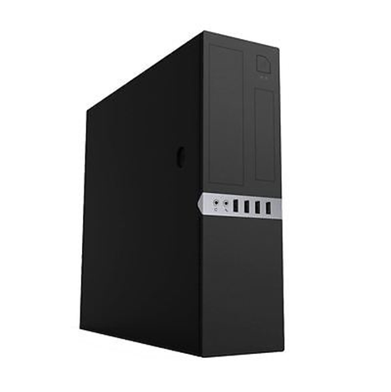

Figure 3 - (CiT)

Figure 3 shows the computer case chosen. It has enough internal space to house all of these components. It has more than enough USB ports, including USB 3.0 ports able to support all peripherals needing USB along with any extras that may be added in future. Some of the USB ports are at the back and are provided by the motherboard, and as can be seen, the case provides its USB ports on the front for easy access.

All of these specifications meet the needs of Ace training. These PCs are capable of running all software that will be run in office.

#### Mac Computer

Also required is a Macintosh Computer for the Marketing Manager.

For the marketing manager, a new iMac with media editing software has been chosen. The iMac chosen is a 21.5-inch with Retina 4K display. This will be useful for editing as the large display and resolution creates more work space. The price of this iMac and final cut pro software is £1,948.99 including VAT.

Specifications explained:

* The chosen Central Processing Unit provides enough processing power to run power demanding applications such as a final cut pro. The i7 processor was not chosen as it would increase the price by £180 and its processing power is too much for what applications it will be used for. This CPU does not have the option for an integrated graphics card. However, the Intel Iris 6200 graphics built into the CPU will provide enough processing power to run most, high demanding applications.
* The RAM has been increased to 16GB to make the editing process much faster.
* A fusion drive has been added as this can make applications run faster, this is because MacOS automatically moves most used applications to the SSD part of the hard drive.
* Final Cut Pro X, this software has been chosen as it is well optimised for MacOS, therefore will be most efficient. This software is used for editing photos and videos.
* This model does not have the option for an integrated graphics card however the intel iris 6200 graphics built into the CPU will provide enough processing power to run most, high demanding applications.

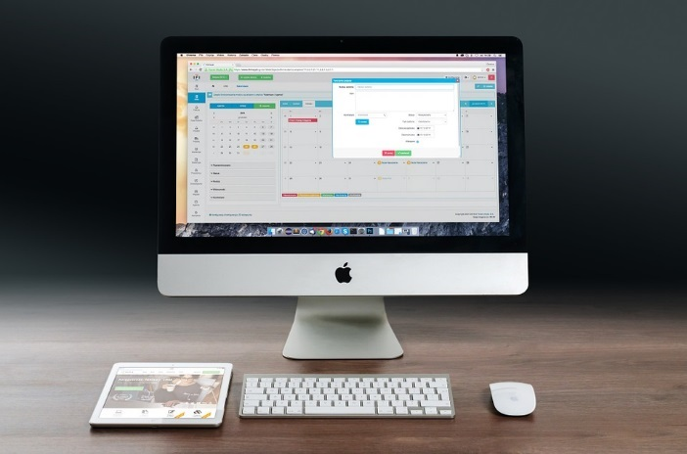

Figure - (Iven, 2014)

|  |  |
| --- | --- |
| Component | Specification |
| CPU | Intel i5 3.1GHz, 3.6GHz Turbo |
| Memory | 16GB 1867MHz LPDDR3 |
| GPU | Intel Iris Pro 6200 |
| HDD | 1TB SSHD Hybrid |
| Case | Apple iMac Case |
| Mouse | Magic Mouse 2 |
| Keyboard | Magic Keyboard |
| Monitor | 21.5” 4K Retina |

Table – Apple Inc.

This iMac has more performance than a typical office PC. This is due to this computer being used for editing media. This is a pre-built solution by Apple Inc.

#### Managing Director PC

The Managing Director requires portability, and so for their purposes, a laptop is more suited. What has been chosen is a Toshiba Portege A30-C-13D. This laptop PC has a long battery life with powerful hardware that will perform well for a long time before needing to be replaced.

The memory and hard disk drive can be easily upgraded in a laptop making it able to run more programs and store more data, prolonging its useful lifetime, although other hardware can be difficult to upgrade. The CPU, in particular, is sometimes soldered onto the motherboard, and even if it is not, the socket used may not be compatible with many CPUs, as laptop CPUs have to be made especially due to desktop versions needed more space for better cooling methods.

This laptop also has an HDMI-out port for outputting the image to an external screen.

### Server Hardware

The Server hardware is mostly pre-built for one main reason. If buying a pre-built server, a redundant power supply is included. Although, even though it is pre-built, the server is what is a barebones build, so a CPU, Memory and HDDs can be chosen. What is included is the motherboard, power supplies and the case, as well as some extras such as an HDD bay.

|  |  |  |  |
| --- | --- | --- | --- |
| Component | Manufacturer | Part Name/Number | Specification |
| Server Rack | LMS Data | CAB-W18U-EL550 | 18U |
| Air Conditioning Unit | Mitsubishi | FH25VE | 2.5kW Cooling |
| Server (Scan 3XS – SER – R12S)   |  |  |  |  |  | | --- | --- | --- | --- | --- | | Component | Manufacturer | Part Name/Number | Quantity | Specification | | CPU | Intel | Xeon E3-1220 | 1 | 3GHz (3.5GHz Boost), Quad Core | | Motherboard | Supermicro | SuperServer 5019S-MR | 1 | Server/Custom | | Memory | Crucial | CT8G4WFD8213 | 2 | 8GB DDR4, 2133MHz | | GPU | ASPEED | AST2400 | 1 | ARM9, 400MHz | | HDD | Western Digital | WD1003FBYZ | 4 | SATA III, 7200RPM, 1TB | | PSU | Supermicro | (Not Given) | 1 | 400W Platinum x 2 and Battery Backup x 1 | | Case | Supermicro | (Not Given) | 1 | (Not Given) | | | | |

Table – Scan Computers International

This hardware chosen is not within the highest tier of hardware that could be used in this scenario as this would be unnecessary at this point and unaffordable, although this hardware is powerful, allowing for growth and for more servers to be added.

### Network Hardware

Network hardware is what makes up the infrastructure of the network. This includes all devices managing, routeing and switching signals between stations. This section will also include any mediums used to move signals between stations and the internet.

|  |  |  |  |
| --- | --- | --- | --- |
| Component | Manufacturer | Part Name/Number | Specification |
| Rackmount Ethernet Switch (Main) | Netgear | GS728TP | 24 Port, Gigabit, PoE, Dynamic VLAN, 192W |
| Small Ethernet Switch | TP-Link | TL-SG108 | 8 Port, Gigabit |
| Ethernet Cable | N/A | Cat6 | 305m |
| Router | Cisco |  | (Provided by ISP) |

Table – Various

### 4.2.4 Other Hardware

#### 4.2.4.1 Printer and Fax Machine

Ace Training is using an outdated fax machine to communicate with their other centre. This is to be updated with a new office all-in-one printer, copier, scanner and fax machine. This machine is manufactured by Epson. The printer is an inkjet printer.

The printer chosen is a “WorkForce Pro Epson WF-8510DWF Multifunction Print/Copy/Scan/Fax Inkjet Printer” (Scan Computers International, 2016). This printer can print and scan pages up to A3 and as small as an envelope, allowing for flexibility. This also connects to the network via Gigabit LAN or WiFi (IEEE 802.11 b/g/n). The maximum rate of printing is 34 pages per minute for black and white and 24 pages per minute for colour, the maximum printing resolution of these is 4800 x 1200 dpi.

This printer is designed to be used by small to medium workgroups as it can handle a lot of throughputs and can produce high-quality prints.

#### 4.2.4.2 Projector and Screen

For the meeting room, it is beneficial to have the ability to have presentations displayed as a large image. To do this, a projector and a projector screen have been chosen that will connect to devices with display outputs and the projector will behave as a display.

The projector chosen is an “Optoma Full HD HD141X DLP 3D Projector” (Scan Computers International Ltd, 2016a) which supports Full HD output using HDMI. It also supports audio input as the projector can play audio. The max refresh rate of this projector is 60Hz; it has a contrast ratio of 23000:1 allowing for clear images to be displayed.

As for the screen, a screen manufactured by Optoma has been chosen. This is an 84” screen with a 4:3 aspect ratio, so there is plenty of display space for presenting. This is a matte white screen that rolls up when not being used to protect the material from any damage (Scan Computers International Ltd, 2016).

## Software Proposed

This section outlines the proposed software solutions for ACE Training LTD the various pieces of software recommended are:

* Customer Relationship Management Solution (CRM)
* Operating Systems
* Accounting Software
* An Intranet/Extranet Solution

### 4.3.1 Operating Systems

This section details the operating systems to be used and their implementation within the Server and all of the Client PCs.

#### 4.3.1.1 Clients

The client PCs are not all the same. Most of these are going to be Microsoft Windows machines, but the one in marketing will be a Macintosh machine, so this section will be further split up.

##### Microsoft Windows Clients

These machines are going to use the latest Operating System that has been released by Microsoft, Windows 10. This is mostly due to services offered and security. Specifically, Windows 10 *Enterprise* will be used, as it is the edition specifically aimed at a business application.

Microsoft Windows 10 offers many features that a business may want to use, plus the functionality needed for the everyday running of applications and access to the internet.

Features within Windows 10 Enterprise applicable to this scenario are as follows:

* Windows Update for Business
  + This is included in all editions; this will deliver security updates so that the business is not vulnerable to attack though client PCs.
* Credential Guard
  + Protects sensitive credentials from being accessed by unauthorised software.
* Trusted Boot
  + This verifies all start-up files from UEFI launch to ensure that nothing is starting with the PC that should not be.

There are many other features, although, these may not be used in this business environment.

##### Macintosh Clients

The computer that the marketing manager will be using is an iMac and will run MacOS Sierra, which is latest OS version. As this operating system is best suited for editing applications. The software is highly secure, as all files can be encrypted by FileVault 2 and the Gatekeeper software can detect unusual behaviour within apps and prevent malicious software from being downloaded.

#### 4.3.1.2 Servers

What has been considered is that the server has a few options for the operating system, most based on either Microsoft Windows or Linux. In this case, however, Linux is not a viable option as the system requirements of the software to be used on the server state that they only support Microsoft Windows Server based operating systems.

At the moment, only Microsoft Windows Server 2012 can be obtained from the server Operating System, although, Microsoft Windows Server 2016 is due to be released soon. This means the cost of Microsoft Windows Server 2016 cannot yet be found. So at the moment, only Windows Server 2012 can be suggested, which is still a viable solution for the needs of Ace Training.

Specifically, Microsoft Windows Server 2012 R2 will be used, it being the latest revision of this operating system.

Microsoft Windows Server allows a particularly important feature called “Remote Desktop” which allows access to the server from a Client PC. Because servers do not typically have Human Interface Devices (HIDs) attached to them, they can be difficult to access, so to see their Desktop and install and use software on them remote access is used.

This Operating System also has up to date security to fit business needs. As soon as a vulnerability is found, updates are released to fix the issue allowing the server to remain secure from attacks.

Microsoft Windows Server 2012 uses “Net Load Balancing” which uses the TCP/IP protocol to distribute traffic across many servers, so no one server is overloaded should traffic spike suddenly. There is also machine virtualisation within this Operating System, allowing many Virtual Machines to be run on the server so remote access from low power client PCs could make use of server computing power should it become necessary.

### Accounting software

Ace training requires new software for that accounts department; these requirements are needed to help improve sales and make sales in a quicker time. Only one computer needs account software and will be run by Microsoft.

#### 4.3.1.1 Sage 50 accounting software

Online accounting software suitable for a start-up business or small business, includes 24/7 phone and E-mail support. Moreover, allows the user to record and sent invoices to their phone. No fixed contract and £25per month including vat.

Sage offers more packages than any other Accounting software

Improves communication and collaboration between all areas of the business and

Enhance productivity, customer satisfaction, flexibility and control Handle operations across multi-national markets.

### Technical details

Sage 50 Standard Online is compatible with:

* Most 32 or 64-bit variants of Microsoft® Windows, 7, 8 and 8.1 and 10
* Microsoft Office 2010 and 365
* Web Workspaces and Summary pages on Chrome & IE v10 and above
* Chrome and tablet devices (ACE training will be using Microsoft software)
* Internet connection with minimum 3.5Mbps download and 0.9Mbps upload speed required.

#### 4.3.1.2 Automatic Bank Feeds

View your current cash balance by using the view your transaction method. Sage, one is securely connect allowing it to be connected for online banking for an accurate view of your business finance and reduce time – consuming tasks as, the software will recognise similar transactions.

#### 4.3.1.3 Performance summaries

Get an overview of key business performance which wold include, sales, cost and profit, built in the countdown, so vat payments are not overdue. See cash flow status within the interactive management screen.

#### 4.3.1.4 Create custom quotes and invoices

Get professional looking invoices and quotes by adding you company logo, email quotes or invoices go directly to your customers within sage and keep up to date with contacts; all are stored in one place using pre-populated information created within the invoices.

#### 4.3.1.5 Tracking monthly income and expenses

Manage transactions by creating income transactions folder keep a record of expense transaction in one place also collect bank activities via the recording of cash deposits and transaction. Speed up bank reconciliation with the automatic process that matches your bank statement your account information. Moreover, automatically record regular and expense types.

#### 4.3.1.6 advanced reports with sage

Sage 50 Accounting offers flexibility with creating report. It can export reports into many formats allowing them to be merged within other reports. It can offer Profit and loss plans which gives information to understand how much money ace training has made and can allow ace training to keep and date on who owes ace training money and who ace training owe money by using the sales invoice and purchase invoice report and allowing data to be calculated while waiting on the outstanding value and the length of the debt.

#### 4.3.1.7 Sage Collaboration

If ace training employees are looking to use another software package or routeing the data by another accountant, Sage 50 Accounting can make collaborating work very easy. It does this by Saving time because the accounts are online rather than paper, the accountant can view data24/7. If there have a problem, Sage will login and guide the user through the problem that is happening. Theone to one service sage offer is you can accountant sign up for their edition of Sage 50, to buy say you can use direct or via your accountant, then choose to subscribe to Sage 50 with Sage or let your accountant subscribe on your behalf and include the charge as part of their costs.

### Customer Relationship Management (CRM) System

A Customer Relationship Management system is an essential tool for businesses, of all sizes and industry types, to build long-term and effective relationships with their clients (Nikolova, 2005). Hence, any Companies that successfully implement CRM will reap the rewards in customer loyalty and long run profitability (Popovich, 2003).

CRM Software consolidates customer data into a single database, enabling business users to access and manage it more easily. Other key functions include recording customer interactions such as emails, phone calls, and social media, automating workflow processes such as tasks, calendars, and alerts and the ability for managers to track performance, productivity and ultimately profitability based on the information stored within the system.

To better understand what a CRM system is, what it does, and what it can do for ACE Training LTD, the different types of customer relationship management encapsulated within the CRM system, such as strategic, operational and analytical will be discussed, and the benefits to ACE training will be given.

Strategic CRM is focused on the development of a customer-centric culture. (Mishra and Mishra 2009) The culture is focused on winning and keeping customers by creating and delivering a better service than their competitors. To achieve this company must allocate resources where they would best enhance customer experiences, for example, allocating extra staff to the sales department if the volume of calls exceeds capabilities, change behaviours such as answering customer queries quickly and efficiently and rewarding such behaviours that enhance customer satisfaction and retention.

With existing systems within ACE Training being outdated and inadequate, for example, customer details being kept by the sales reps on Rolodex, sales being recorded on paper and stored in filing cabinets, it is challenging for ACE Training to become customer-centric. As stated above for company to become customer-centric they must allocate resources where they would best enhance customer experiences. Due to the way in which data is stored, it would be an ineffective and inefficient process to generate reports and would, therefore, make it a near impossible task to gain an understanding of where to allocate resources where needed. Also, due to the same reasons, it would be impossible to reward behaviours that enhance customer satisfaction.

Implementing a CRM system will greatly enhance customer-centric culture within Ace training as all customer details and correspondence would be stored within the CRM database. Thus, enabling the users to have access to it at all times, giving them the ability to make informed decisions quickly and efficiently.

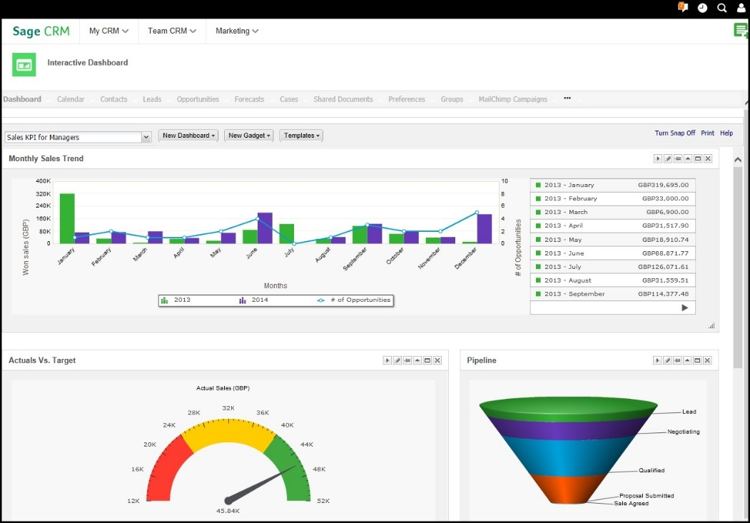Also, through the use of management dashboards, a CRM system would aid managers in the allocation of resources and the rewarding of behaviours necessary for a company to become customer-centric. The dashboards come as standard for all CRM solutions and give managers real-time insight into business activities such as sales and service. An example of which is shown in figure 4.

Operational CRM concentrates on automating and improving customer facing and customer supporting business processes such as Marketing, sales and service. (Mishra and Mishra 2009)

Figure – CRM Management Dashboard

* **Marketing automation** applies technology, by the use of a CRM software application, to marketing processes. Enabling marketers to use customer data to develop, execute and evaluate targeted communications. Thus, enabling the marketer to offer event-based, or trigger, marketing.

Event based marketing is a term used to describe messaging and offer presentation to customers at a particular point in time. (Popovich, 2003)Initiated by, either, customer behaviours, such as buying patterns, or contextual conditions such as the birth of a child or public holidays.

At present Ace Training LTD’s marketing departments mailing list is kept off-site by a third party, making It difficult to retrieve, modify and ultimately, analyse the data being held. Without the ability to analyse customer data it would be an impossible task to implement targeted marketing campaigns such as event-based or trigger marketing.

CRM software would allow the marketing department, again through the use of the GUI, to monitor their existing customer base and also prospective clients. As it would enable the marketing team to recognise trends in the market, either falling or rising, before they reach their climax and, thus, allowing them to target such trends.

Also, CRM software now incorporates tools to monitor social media channels such as Facebook and Twitter. This ability allows the marketing team to monitor said channels for their name being mentioned and provides them with the capacity to reply to said comment and give an explanation if it is derogatory. Monitoring social media will also enable Ace Training LTD to target and capture new business, for example, if a company posts on their page about purchasing a new building or they have updated their IT infrastructure.

* **Sales-force automation**, as discussed, was the original form of operational CRM. SFA applies technology to the management of a company’s selling activities (Buttle, Sales-Force Automation 2009), such as lead generation and qualification, proposal generation and presentation, and the closing of the sale.

Currently, the manual sales processes within Ace Training LTD are resulting in too few calls being made, calls being missed, sales targets being missed and, ultimately leading to the sales team moral being adversely affected due to low wages.

The implementation of SFA will enable Ace Training LTD to automatically assign leads to the relevant staff member, for example, a sales person who is assigned to a particular area, track opportunities as they progress towards closure, and, if lost, the ability to determine why it was lost.

Also, SFA systems allow its users to manage their communications with customers. Contact management has features that automatically generate reminders to contact clients which have been inactive for specified amount of time and customers who are part way through the sales process who require a follow-up email or phone call.

Therefore, the implementation of CRM software will greatly increase sales efficiency, giving the sales team the opportunity to meet their sales targets, increase their wages and significantly enhance moral.

* **Service automation** allows organisations to manage their service operations, whether delivered through a call centre, web or face to face (Mishra and Mishra 2009). Ace Training LTD have not specified any issues in this area, but the inefficiencies in other areas will translate to inefficiency within the service department.

The implementation of CRM software will allow Ace Training LTD to handle and coordinate their service communications across all of the above channels. Thus, enabling the users to handle service operations more efficiently and effectively. Therefore, improving service quality, enhancing productivity, reducing service costs and, increasing customer satisfaction and, ultimately, greatly improving customer retention.

Analytical CRM is concerned with capturing, storing, extracting, integrating, processing, interpreting, distributing, using and reporting customer-related data to enhance both customer and company value. (Mishra and Mishra 2009)

Analytical CRM builds on the foundation of customer related information, both, stored within the company and, possibly, from external sources such as lifestyle data from business intelligence organisations. With the application of mining tools, a company can analyse customer-related data such as sales, financial, marketing and service data and build a complete picture or gain a 360° view of their customers. Enabling the business to answer fundamental questions such as; Who are our most valuable customers? Which customers are most likely to switch to a competitor? Which customers are most likely to respond to a particular offer?

From the client's point of view, analytical CRM can deliver timely, customised, solutions to the customer’s problems, thus enhancing customer satisfaction. From the Ace Training LTD’s perspective, analytical CRM offers the prospect of more powerful cross-selling and up-selling programmes, and more effective customer retention and customer acquisition programmes (Buttle, Developing Managing and Using Customer-Related Databases 2009).

Although ACT! Sage CRM was the preferred CRM solution for ACE Training LTD; the proposed CRM system will be Sage CRM. Sage entered the CRM market, with Sage ACT!, in 2002 after purchasing Interact Commerce. After Swiftpage took ownership of ACT!, Sage then began distribution of its CRM solution (Act Today 2009).

Sage CRM offers all of the same features and functionality as other CRM solutions such as sales automation and also provides the same deployments such as web or mobile via an app (Sage n.d.).

Sage CRM, however, offers an out of the box integration with Sage 200 accounting software (Sage n.d.). With this additional feature, Ace Training LTD has the opportunity for a further increase efficiency and also the integration of the software packages will reduce or eliminate the need to duplicate customer information across departments.

Sage also offers onsite support and training subject to an additional fee usually, according to www.crmsearch.com, in the range of 15% to 21% of the retail price (crmsearch n.d.). The training and support include a Sage expert coming to the business to go through the business processes, ensuring Sage software is setup correctly, fixing any issues and advice on best practice and improving efficiencies (Sage n.d.).

Furthermore, due to the 47% failure rate of CRM implementations, it is recommended that the training of team members be carried out by Sage, as Sage know their softwares capabilities, limitations and can advise on the installation and setting up of the software. The training and support include a Sage expert coming to the business to go through the business processes, ensuring Sage software is setup correctly, fixing any issues and advice on best practice and improving efficiencies.

### Intranet/Extranet Options for Ace Training

Ace Training is a company that delivers technical computer training courses. They have a training centre in Manchester, and they also go to customer premises throughout the UK to conduct training.

One of the main tools that any training centre will use, like in University or School, is PowerPoint presentations. These are used to help back up what the teacher is explaining. It is also important that all students of Ace Training have somewhere where they can see lecture notes, access the PowerPoints used in classes and upload work and assignments they have to do for their courses.

For these reasons, we believe it is important for Ace Training to implement the use of an Extranet or Intranet for their training services.

#### Intranet vs. Extranet

An intranet is a network where employees can create content, communicate, collaborate, get stuff done and develop company culture. Whereas, an extranet is similar to an intranet, but also provides controlled access to authorised customers, vendors, students and staff. (Eisenhauer, 2016)

For our purposes, we will need an extranet system. This will allow for student and staff access to content to be controlled. Obviously, it does not make much sense for all students to be able to look at results, solutions and other content that could be protected under the Data Protection Act 1998 (The Stationery Office, 1998).

Different options available for Extranet systems are vast and come with different features, advantages and disadvantages. These include price, which is the biggest factor to consider.

#### Moodle

We have decided that the best software for Ace Training be Moodle. Moodle is a learning platform designed to provide educators, administrators and learners with a single robust, secure and integrated system to create personalised learning environments. You can download the software onto your web server or ask one of the Moodle engineers to assist you, although this will come at a cost. For a Moodle Engineer to get you completely up and running with a Moodle system, it will cost £500, and you also have the option of paying monthly instalments (Buchner and Bchner, 2008)

The reason we have chosen Moodle is that it is free, with no licensing fees, it is used by tens of thousands of learning platforms worldwide, it is an all-in-one learning platform and above all else, is it very easy to use.

Because it is open-source, Moodle can be customised in a way that will suit the user. Ace Training can add plug-ins and hyperlinks to their Moodle server that will allow students and staff to access anything that is needed for classes.

Figure - Ace Training Staff Profiles



Moodle has features for Management level, teacher level, student level and even Parent level login. Below is a copy of Ace training company hierarchy. This shows that there is a different level of authority in the company and that they could make use of the different levels of access on Moodle’s platform.

Staff profiles will be included in the extranet, which will be updatable and as staff information may change at any time, Moodle is the perfect platform to do this.

The diagram of the staff hierarchy has been added to this section to outline that there is a need for access control, it is shown in figure 5. This is mentioned in the technical security section, as it is clear that there is a need to control who can access certain profiles and information on the Moodle system.

## Security Considerations

Security of a network and the data contained is of utmost importance to all parties involved, either the organisation that is storing the data or the individual of which the company is storing his or her personal information.

Any breaches in security may cause real harm or distress to the individuals they affect and could even put lives at risk. However, not all security breaches have such grave consequences, but many cause less severe embarrassment or inconvenience to the persons concerned. Of course, breaches in security will not just affect the individual the organisation involved may be subject to loss of confidence by customers resulting in lost opportunities and ultimately prosecution under the Data Protection Act 1998.

The Data Protection Act 1998 states, under Principle 7-Security, “Appropriate technical and organisational measures shall be taken against unauthorised or unlawful processing of personal data and accidental loss or destruction of, or damage to, personal data”. (Gov, 1998).

In Practice, the above principle means the company must have appropriate security to prevent the personal data kept being accidently or deliberately compromised. The organisation must take steps to design and organise security to fit the nature of the personal data held and also the harm a security breach may cause. They must be clear about who in the organisation is responsible for information security to ensure the right physical and technical security is in place and be ready to respond to any breach of security swiftly and efficiently.

Network security takes two forms software security and physical security. Software security provides barriers and other tools that protect programs, files and the flow of information to and from a computer.

Hardware security protects the machine and peripheral hardware, such as hubs and switches, from theft, electronic intrusion and damage.

In the following section, the proposed physical, and technical security considerations for Ace Training LTD will be explored.

### Physical Security

For physical security, it is best to firstly consider what entry points there are to premises that contain valuable equipment. These entrances should be regularly secured with strong locks and sufficient structure to stop brute force. Although, these are not full proof and an intruder could get inside. With this in mind and due to the server/switch room being located near the rear service entrance, the rear service entrance door may need to be changed in order to secure the building and its contents further.

t Physical security of equipment can be as easy as confining computers, servers and switches or hubs to a locked room, and restricting access to only those who are authorised. If it is not possible to lock computers away in a secure location, they can be locked in place via a chain or steel cable.

#### 4.4.1.1 Server/Switch Roomt

The server/switch room, formally the store room, currently has double doors and is open to all Ace Training LTD employees. The proposed security solution is to split the store room in half, with a stud wall, keeping the double doors for the store room and creating a new door for the server/switch room (figure 5). Also, for additional security, the suspended ceiling in the new server room will be replaced with a standard solid ceiling, thus, preventing intrusion from above.

The wall and ceiling will be constructed using Gypframe Ceiling channel and Gypframe stud, this method was chosen over traditional timber frame methods as it is quicker to construct and power tools are not required to cut it, therefore, this method will not require any down time when installing.

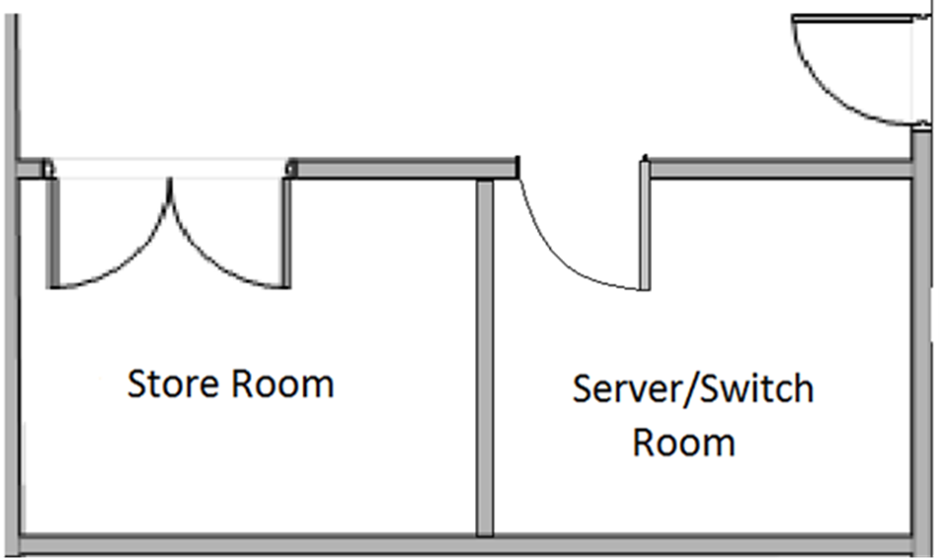

Figure - New Layout for Store Room and Server/Switch Room

Furthermore, to fully secure the server/switch room, a high-security door with a code lock will be installed. The installation of a high-security door will help prevent any unauthorised access and, in the event of a break in, intrusion into the server room, therefore, preventing any loss or electronic intrusion to the data being held.

A Code Lock 2210 electronic Mortice Lock will be used in conjunction with the high-security door. The CL2210 is a medium duty electronic lock. When an unauthorised code is entered, the outside knob turns freely without operating the latch bolt. When a valid code is entered, and the blue LED lights burn, the knob will retract the latch bolt. In the event of power loss, an override key will open the door for management functions.

The Code Lock 2210 has been selected over a traditional mortice and mechanical code locks due to the risk of keys being lost, stolen or copied and due to the ability for authorised personnel to use their own unique code to gain access.

#### 4.4.1.2 CCTV

Another consideration for security for Ace Training is the installation of a CCTV system. The CCTV system installed would record throughout the day and night, keeping a set number of previous hours of footage so that any incidents are caught and can be used to, either, prosecute intruders or to reinforce any access points where unwanted activity has been identified.

The proposed CCTV Cameras will be installed internally at each entrance to the premises as these are the weak points and the most likely access points to the premises. To secure the server room, a further two cameras will be installed, the first will be fitted inside the server room to guard against any unauthorised access to the servers and switches and the last being installed externally to cover the rear entrance as this entrance is located in close proximity to the server room and, as it is the rear entrance, would be the most likely access point to intruders who wish to gain access.

The CCTV system that has been selected for ACE training is the Domar complete CCTV Solution. The system contains a Zxtech 8 channel HD DVR with a 1TB hard drive, five internal/external Sony Effio-e infrared day & night colour CCTV cameras, and an HD monitor. Also, included in the package is 3 x 10m and 2 x 20m CCTV cable and power splitters.

The CCTV system from Domar was selected mainly due to the 1TB HDD, giving Ace training the ability to five days of continuous footage from each of the five cameras.

#### 4.4.1.3 Desktop PCs

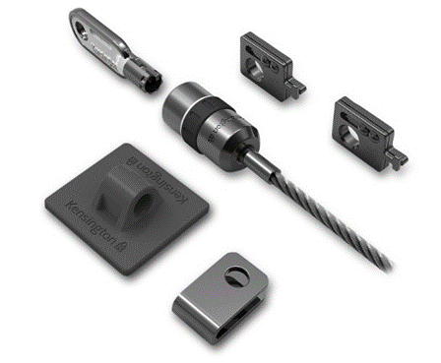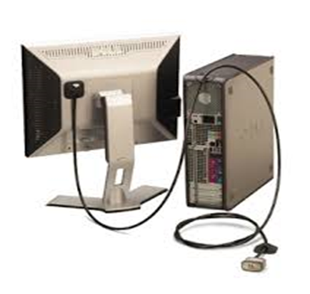As stated, the easiest way to secure mission critical equipment such as PCs would be to lock them away in a secure location. In this case, however, locking the equipment away would be impractical and time-consuming. With this in mind, the decision was made to secure the PCs and other equipment, such as printers, in place using a cable lock system (Figure 8).

Figure 8 Cable Lock system

Figure 9 PC Secured using Anchor Plate

All Kensington locks are built to exacting engineering standards. This lock is rated as Safe Safe-Locks engineered and tested to Kensington's exacti-Pro rating. Which is a rating awarded to Kensington Security Locks that are tested under rigorous test conditions by third party testing agencies for their ability to withstand attacks.

With a long high-carbon steel cable, anchor plate, and a keyed lock, the Desktop and Peripherals Locking Kit has everything needed to secure a desktop computer, and two peripherals, such as a Wired keyboard and mouse. Devices without a Security Slot can be secured by the use of an anchor plate (Figure 9).

The locks are provided with two keys for each standard lock. The keys are stamped with a unique code enabling the user to request a new key from Kensington if lost. Kensington locks are made with high-carbon steel cables and tested under real-world conditions to resist lock-picking, corrosion, tampering and extreme environments.

(See Appendix C for full breakdown of physical security measures, costs and installation schedule)

### Technical Security

As with any network system, security is key to ensuring safeguarding, access control and data loss prevention. There are lots of different ways to protect a network, all of which we will consider for Ace Training.

"Network security" refers to any activity designed to protect the usability and integrity of your network and data. It includes both hardware and software technologies. Effective network security manages access to the network. It targets a variety of threats and stops them from entering or spreading on your network(Rhodoes-Ousley, 2013).

#### Access Control

There will be lots of users who have access to ace training files and documents. From the staff of Ace Training – right through to the students whom they teach.

Not every user should have the same access to the network, and to keep out potentially dangerous users and viruses, each user and devise need to be recognised.

Limited access should be given to non-crucial users. This includes access to the network through internet usage and access to the intranet system.

Student access will be very limited; they will be able to log onto the network and view some controlled documents. With regards to uploading data, this will again be very controlled. Students will be able to upload PDF documents to the Moodle system.

Someone within the company will be given the responsibility of System Administrator. They will be in charge of NAC (T*he knack of NAC [Network access control]*, 2007).

The data protection act needed to be adhered to with regards to Access control, for instance, personal information about employees and students should be kept by employers, but only accessed when required.

#### Email Security

Email Gateways are a big threat to networks as they are a clear route into a server through users. Attackers use personal information and social engineering tactics to build sophisticated to deceive users and send them to sites serving up malware. For this reason, Ace Training Internet security is vital to ensure there will be no corruption in the system.

Any emails containing websites links will be regarded as spam until the user accepts them. Any websites that contain malware will be blocked by the system administrator, and suspicious websites will be filtered to prevent access.

As users, will need email usage, we will be using Microsoft Outlook. This has been chosen for Ace Training as they mostly Microsoft Windows clients, and as mentioned in the Operating Systems section of the report, this protects users from access by unauthorised software.

#### Data Loss Prevention

Data loss can diminish a company's brand, reduce shareholder value, and damage the company's goodwill and reputation. (Liu and Kuhm, 2010)

Sensitive data will need to be stored by Ace Training. This includes salaries, contact information of staff and pupils, hierarchy-controlled information like company profits and staff files. For this reason, it is important that access to this type of information stay under “need to know” access control.

Today there is technology available known as DLP or data loss protection, that stops certain users from sending, copying and even printing vulnerable information.

Basic FTP can be used to stop vulnerable data from being accessed by unauthorised users, and it is also recommended that someone from the company will be put in charge of file backups on the server, to ensure that no data is lost in the case of a security breach.

#### Firewalls and Anti-Virus

Firewalls put up a barrier between your trusted internal network and untrusted outside networks, such as the Internet. They use a set of defined rules to allow or block traffic. A firewall can be hardware, software, or both. (Frahim and Santos, 2009)

There is lots of Firewalls and Anti-virus software available for small business’ like Ace Training, and when choosing something that will suit, it must be noted that because there is the use of Mac and PC at Ace Training, something that will protect both is needed.

Symantec Endpoint Protection is recommended for Ace Training. This is Norton’s main business Anti-virus software, and although it is not the cheapest on the market, it has a whole host of features that make it the ideal selection. This is run by Symantec and offers multi-layers of protection, including antivirus, browsing protection, firewall, application control, device control and remote management. It allows for between 1-350 users and the standard licensing period is between 1-3 years.

Other layers of protection include behaviour monitoring, intrusion protection and the 'Power Eraser' to remove stubborn threats and repair your system.

A three-year subscription costs £760, which is only £253 per year. This is an ideal solution, and the benefits are listed below:

* Delivers the same security trusted by the world’s top companies.
* Protects data across devices — desktops, laptops, tablets and smartphones.
* Offers easy cloud-based setup and device management.
* Gives 24x7 support for you and your employees.

(Norton, 2016)

This has been compared to main competitors AVG and McAfee and is considerably cheaper in price.

For the same amount of cover on 20 devices, for one year of cover, AVG business Edition costs £437.33 excluding VAT, and McAfee Endpoint Business costs £580 for 20 devices.

#### Software Procedures and Policies

These procedure recommendations have been suggested to reduce the risk of malware, hacking and wrong-doers from entering the server. Following these procedures is recommended, and we believe deliberately going against such procedures should be dealt with as a matter of misconduct by the employee or student.

1. Users must have a password of at least eight characters, and regularly update password when prompted. Password must remain securely with its user and not be given out to any other user to use their login. Any user found to be on someone else’s login should be disciplined.
2. Users must not download any software from unregulated sources. The only administration is allowed to put software on the PCs unless otherwise advised.
3. Fair Use policy must be in place-

* No Gambling websites used in the workplace, not even on personal devices
* No adult material viewed or shared.
* Social Media should not be used unless during scheduled break times.

1. Only company based email addresses should be used on the company PCs, for example, “joebloggs@acetraining.org”.
2. Management has the right to access and read all employee emails, sent and received.

### Installed Application Security

#### Sage CRM

Security within the CRM system is maintained by the use of privileges and access levels for the various entities. The privileges and levels of access are regulated by the administrator who can both grant and revoke privileges or access levels at any time.

Privileges are the basic security units that determine what action the user can perform on the CRM system. These can only be modified so cannot be added or deleted. The common privileges available within CRM systems are as follows, create which allows the user to add a new record, read enabling users to view a record, delete allows the user to remove a record, append which allows a user to attach other entities to, or associate other entities with a parent record (Buttle, Developing Managing and Using Customer-Related Databases 2009).

Levels of Access determine the records of an entity upon which the user can perform a given privilege. The 5 levels of access are None were no privileges are given, User giving privileges to, only, the records owned by or shared with by the user and includes the privileges belonging to the team to which the user belongs, Business Unit giving privileges for all records owned by the business unit to which the user belongs, such as sales, and Organisation which provides privileges for all the records within the organisation regardless of who owns it.

#### Sage 200

* Accounts are protected by username and software.
* SAGE Will Log out a user if they are inactive for an extended period.
* Sage 200 operated behind an industry standard firewall.

#### Mac Security

The computer contains software called Gatekeeper. This, “makes it safer to download apps by protecting you from inadvertently installing malicious software on your Mac”, (inc, 2016). Software downloaded from the internet can get “unique Developer ID from Apple and use it to digitally sign their apps. The Developer ID allows Gatekeeper to block apps created by malware developers and to verify that apps have not been tampered with.”, (inc, 2016). Gatekeeper will block any applications from being downloaded which is developed by an unknown developer.

FileVault 2 can encrypt entire hard drives using “XTS-AES 128 encryption”, (inc, 2016). If the computer was to be reused by someone else, FileVault 2contains a feature which removes data on hard drives, “Instant wipe removes the encryption keys from your Mac — making the data completely inaccessible — then proceeds with a thorough wipe of all data from the disk.”, (inc, 2016).

Software called App Sandbox in MacOS is used to isolate applications from “critical system components”, (inc, 2016), personal data and other applications. App Sandbox blocks any applications with malicious software preventing it from infecting the computer, as well as plug-ins in the Safari browser.

MacOS contains runtime protections; this protects the “memory used for data and memory used for executable instructions.”, (inc, 2016) this protects the computer from malware. “Address Space Layout Randomisation (ASLR) changes the memory locations where different parts of an app are stored.”, (inc, 2016). This defence works at all levels of the Mac and prevents attackers from rearranging parts of an application to cause harm to the computer.

## User Training

### Software

#### Sage CRM

The training is key to the successful implementation of CRM solutions. A 2009 survey by Forrester found a failure rate of 47 percent (Mishra and Mishra 2009) due to common factors such as lack of focus, lack of commitment and approaching CRM as a technology-only solution. Adequate training in these areas will aid the company in the implementation of the CRM System and realisation of its goals.

Due to the 47% failure rate, in the first year, of CRM implementations, it is recommended that the training of team members be carried out by Sage, as Sage know their software’s capabilities, limitations and can advise on the installation and setting up of the software. The training and support include a Sage expert coming to the business to go through the business processes, ensuring Sage software is setup correctly, fixing any issues and advice on best practice and improving efficiencies.

## Support Staff

### IT Support Staff

Ace Training already has their own IT support staff. After being briefed on the system that will be put in place, they can manage the server. Although, this IT support is not based within the Liverpool Building and so, it is recommended that the sales assistant manager has some training in system administration as they appear to have had experience. They will then be able to manage the network hardware, server and software.

## 4.7 Server Management

Ace Training already has staff that are qualified to manage a server. So, these staff will be used to manage the new server in the Ace Training office.

## System Maintenance

### Server Maintenance

Server Maintenance is of the utmost importance. Because Ace Training deals with financial details, server security must be kept up to date. So many different parts of the server must be regularly maintained.

This task can be broken down into many sub-tasks:

#### Regularly Updating OS

Updates for server operating systems are very important for server security. So having these updates applied to a server immediately is very important for securing any vulnerabilities in the system. If updates are not applied quickly, the server remains vulnerable to any attacks to steal information.

#### Remove Old/Obsolete Data

Data that is no longer used, such as old user accounts, will fill up the server over time, eventually slowing the access and processing of data of not properly maintained. The system must be kept free of old data, removal of old useless data is necessary to keep the server running well.

#### Check RAID Integrity

The server at Ace Training will use RAID with its storage, specifically RAID 6, as this much like RAID 5 distributes parity between all disks. RAID 6 has no performance hit on read operations but does have performance penalties on write operations, but this would not be a problem at Ace Training as data write operations will not be constant. This will allow for secure storage of data with minimal losses. RAID is not an infallible system, however; it can have failures. This is why it is part of the server maintenance routine to check on the status of the RAID configuration. If this is not checked, and a drive fails, data loss will occur, no matter what RAID is used.

#### Program Updating

Just like the operating system, programs running on a server will also require updating. These may also be to secure vulnerabilities in the system. So even if an operating system is up to date, a program may allow data breaches to occur if not secure.

#### Hardware Error Checks

Logs will be kept by the system of any details of hardware events. These logs should be checked regularly to ensure that there are no failures in the hardware of the server. These logs could signal that certain components need replacing. For instance, regular issues accessing memory locations could signal that a RAM stick needs replacing.

#### Utilisation and Limits

Regular checks for server utilisation such as CPU and disk usage should be checked, among other details. This is to ensure that the server is not being overused. Otherwise, the performance will need increasing, and additional components/more powerful components should be added.

### PC Maintenance

##### Backup Data

Backing up data is very important for a PC. Should the operating system fail to start up, it is a good idea to have a backed-up image file to go to re-install the OS. Also, important files should be backed up if storing them on a PC, although, in this case, this will not be so much of an issue as data will be stored on the server which can manage its backup/RAID solutions.

##### Warranty

Especially in the case of having many PCs in an office, the warranty can save on the cost of replacement of parts. It is worth regularly checking or keeping track of warranty for all parts. If a part should fail and it is not covered, then that part will have to be replaced outright, which is usually far costlier than a replacement under warranty.

##### Anti-malware

Various programs can assist with this issue as client PCs downloading malware, even within a local network, as long as an internet connection is being used these are at risk. Microsoft Windows now features its own antivirus as well as prompts when programs attempt to edit the operating system or run/install programs. Although, a live tracking program is usually the best solution to have running, which will constantly monitor activity for any malicious software.

##### Overheating

Dust is an issue for all electronic devices that require cooling. As long as there are openings into the circuitry and heatsinks/fans, dust will get into the electronics. This impedes the transfer of heat away from high TDP chips, and they can overheat and become damaged, or they may perform thermal throttling and affect their own performance.

To solve this, regular maintenance to remove dust from all computers is required. This just involves opening the case and using canned air to remove any dust with short sprays. Although fans should be held while this is done as spinning them manually can damage them. Also, the thermal paste should be replaced on CPUs very occasionally; this is usually only an issue when a dust free PC begins to experience overheating.

### 4.8.3 CRM System Maintenance

The maintenance of CRM systems is of utmost importance to companies, as it does no take long for databases to degrade and adversely affect data integrity (Buttle, Developing Managing and Using Customer-Related Databases 2009). The reasons for the degradation are due to customer-related data continuously changing. For example, in the UK Almost, 5,000 changes are made to the postcode file every day as people move home and new businesses. That adds up to 1.3million changes every year (Manger 2014). Moreover, in the UK, an average of 1.2% of the population die in a year (McLarren 2016).

However, companies can maintain their data integrity in some ways such as;

* Ensuring data from new transactions, marketing campaigns and, leads is, backed by rigorous policies and procedures, inserted into the database immediately.
* CRM administrators should regularly de-duplicate the database. Even in well-managed databases data duplication or redundancy will occur (Buttle, Developing Managing and Using Customer-Related Databases 2009). However, CRM systems enable the administrator to identify duplications, take the most recent values from the duplicates and, merge them to form a single record.
* Purge customers who have been inactive for a predetermined amount of time. This being imperative to ensure data held is relevant. Also, it is a requirement under the data protection act 1998, to remove customer records if they request it.
* Get customers to update their records or implement procedures for company representatives to check customer details whenever they contact or are contacted by the client.

Maintaining the database means that users will be more likely to have their need for accurate and relevant data met.

### 4.8.4 Network Management

It is recommended that the system administrator be trained to be able to manage the network hardware, for example, the switches. This would be more cost effective for Ace Training, as it can be more expensive to hire a technician. The course will take up to 7 days and can be done either online or in a room.

## Benefits of the Solution

### Hardware

This section will discuss the benefits of the chosen hardware for Ace Training.

#### Client PCs

##### Issue

The problem at Ace Training was that their PCs are too old and would have trouble running modern day applications. Another issue is that lots of work were being done on paper when it needs putting into a computer which is more efficient and easier.

##### Requirements

The requirements of this issue are that new PCs are brought into the office that are able to not only run modern day applications but also to be futureproofed to some extent due to Ace Trainings growth as a company. These PCs need to be able to keep up with modern applications and services and to be reliable. Also, more PCs are required than are currently present at the office.

##### Solution

Hardware has been chosen at the component level. The PCs chosen are custom built to ensure that each component is able to perform all tasks needed. These are also built to be upgraded with newer hardware in the future if needed. The cases are large enough to fit in larger hardware, such as PCIe cards, but low profile enough to not take up too much space on a desk. The case can also support larger cooling systems or more hard drives, although, currently, the stock cooler that comes with the CPU will fit the needs of Ace Training. The socket used on the motherboard is able to fit a large variety of CPUs to enable upgrades to higher models when needed, for instance, the CPU in the Client PCs, an Intel Pentium, can be upgraded to an Intel Core i3 if more performance was needed. The Client PCs are also fitted with a PCIe Wi-Fi card which enables communication between the router and all of the PCs if the Wired LAN were to fail. The motherboard also is able to support a maximum of 16GB of memory, with 8GB installed, which is more than enough for even the most strenuous tasks that general office tasks would demand currently, in conjunction with the CPU.

#### Server

##### Issue

The problem at Ace Training with reference to a server was that they do not have one. They are currently using paper-based methods of storing data.

##### Requirements

The requirements of this problem is that a server able to handle the load that Ace Training will put onto it is needed. This goes for at least peak demand.

##### Solution

The solution to this problem is that two semi-prebuilt servers have been chosen to be implemented (two of the same server blade). These servers will include powerful hardware and plenty of storage (in the order of Terabytes) to accommodate Ace Training’s needs. These servers will be put into a server rack that can accommodate 18 servers in total, should more need to be purchased. Also, these servers are upgradeable, so if performance starts using most system resources or runs out of storage, a more powerful CPU/more memory can be installed, and more hard drives/larger capacity hard drives can be installed.

The amount of storage used is 4TB split into four 1TB hard drives, allowing for lots of storage, but split across many drives to allow for plenty of redundancy using a RAID solution. The CPU is an Intel Xeon E3-1220, this is a very capable CPU for the needs of Ace Training. This was chosen over the E5 series as an E5 Xeon CPU is clocked at a much lower frequency than an E3 (Intel Corporation, no date) and some programs needed by Ace Training require a higher clock speed. An E7 Series Xeon CPU was not chosen due to the very high cost and the fact that they have much more performance that is more applicable to a large business with a server that server many more users.

### Network Technology

#### Issue

A network solution is required by Ace Training to help increase, productivity, sales and work efficiency.

#### Requirements

The requirements are network hardware to form a local area network, to connect all devices. An Internet service provider to provide a secure fast connection to the internet.

#### Solution

The benefits of this solution are that it provides a secure, fast and efficient network for Ace Training. All staff can access the server and client details. This increases the speed of sales being made. The switches and Ethernet cable recommended provide 1Gbit/s transfer speeds; this will make data access much faster than the pen and paper method currently used by Ace Training. If a switch does go down other switches will still function so that departments can continue their work. Devices can also access the network via the Cisco router provided by Virgin Media.

Virgin Media will be managing and monitoring the internet connection, so keeping the connection secure due to their security methods and the use of a leased line and VPN which keeps the connection private, secure and guarantees the 300Mbit/s symmetric speeds. Provides the office access to the Internet, allowing for much better marketing and sales. This will also allow for a much better sales system as the sales team can communicate with customers via the internet, therefore creating a much faster method of communication increases sales performance.

## 5.0 Total Costs

### 5.1 Networks Hardware

|  |  |  |  |  |
| --- | --- | --- | --- | --- |
| Product | Amount | Cost | Supplier | |
| Cat 6 shielded Ethernet cable | 305 meters | £123.84 | Cabling4less | |
| Ethernet cable boots | 44 | £5.28 | Cable Monkey | |
| Wall Ethernet modules | 22 | £54.50 | Screwfix | |
| Virgin Media internet access | 1 Year subscription | £146.88 | Virgin Media | |
| NETGEAR GS110TP v2 ProSafe 8-Port Smart Gigabit PoE Switch w/ 2x Gigabit SFP Ports (59.3W) | 2 | £204.34 | Broadbandbuyer | |
| NETGEAR GS728TP ProSafe 24-Port Smart Gigabit PoE+ Switch w/ 4x SFP Ports (192W | 1 | £312.26 | Broadbandbuyer | |
| Trunking: end caps, corner pieces, coupler, trunking and no nails glue | 1 | £735.57 | Screwfix |
| Cable tray: trays, zip ties, earthing strip and supports | 1 | 142.98 | Direct channel | | |

Table – Various

## 5.2 Server Hardware

|  |  |  |  |
| --- | --- | --- | --- |
| Product | Amount | Cost | Supplier |
| 3XS-SER-R12S Server | 2 | £2002.68 | Scan Computers |
| Server Cabinet | 1 | £134.99 | Scan Computers |
| Mitsubishi FH25VE AC | 1 | £947.70 | Amazon UK |

Table – Scan Ciomputers International

## 5.3 Client PC Hardware

|  |  |  |  |
| --- | --- | --- | --- |
| Product | Amount | Cost | Supplier |
| CiT S503 | 20 | £25.99 | Scan Computers International Ltd |
| Intel Pentium G3250 | 20 | £53.99 |
| AS Rock H81M-DGS | 20 | £42.98 |
| Corsair 4GB 1333MHz RAM | 20 | £23.99 |
| CiT 400W PSUCIT400MICRO | 20 | £16.99 |
| Keyboard & Mouse | 20 | £17.99 |
| Mouse mat | 20 | £4.99 |
| Monitor | 20 | £119.99 |
| Video Cable | 20 | £10.99 |
| PCIe WiFi Card | 20 | £29.99 |
| iMac 21.5 inch 4k Retina Display | 1 | £1948.99 | Apple |

Table – Scan Computers international, Apple Inc

## 5.4 Other Hardware

|  |  |  |  |  |
| --- | --- | --- | --- | --- |
| Item | Unit Cost | Quantity | Total Cost | Source |
| Printer/Fax Machine | £725.99 | 1 | £725.99 | Scan Computers |
| Print/Copy/Scan/Fax, Inkjet, 4800 x 1200 dpi, A3 | | | | |
| Projector | £889.99 | 1 | £399.99 | Scan Computers |
| 1080p, 23000:1 Contrast Ratio; HDMI, VGA(D-Sub), Audio Player Support | | | | |
| Projector Screen | £121.00 | 1 | £121.99 | Scan Computers |
| 84” across, Matte White, 4:3 Aspect Ratio | | | | |

Table - Scan Computers International

## 5.5 Software

|  |  |  |  |  |
| --- | --- | --- | --- | --- |
| Product | Users | Cost Per User | Total Cost | Supplier |
| Sage CRM | 13 | £400 | £5200 | Sage UK Ltd |
| server | £1200 | £1200 |
| Sage CRM Training | 13 |  | £1344 |
| Total | | | £7744 |
| Sage Accounting Software | 2 | £300 | £600 | Sage UK LTD |
| Sage training | 2 | £220 | £440 | Sage UK LTD |
|  |  |  |  |  |
|  |  |  |  |  |

Table – Sage UK Ltd

## 5.6 Security

### 5.6.1 Physical Security

|  |  |
| --- | --- |
| Task Description | Cost |
| Server/Switch Room | £783.40 +VAT |
| Security Door and Lock | £581.80 +VAT |
| CCTV | £564.75 +VAT |
| Kensington PC Locks | £563.80 +VAT |
| Total Cost | **£2493.75 +VAT** |

Table - Various

### Technical Security

|  |  |
| --- | --- |
| 1. Task Description | Cost |
| Symantec Endpoint Protection | £760 +VAT |
| Total Cost | **£760 +VAT** |

Table – Symantec Corporation

### Grand Total

|  |  |
| --- | --- |
| Description | Cost |
| Network Hardware | £2386.21 |
| Internet Service Provider | £8400.00 |
| Server Hardware | £5088.05 |
| Client PC Hardware | £6358.00 |
| Other Hardware | £1247.97 |
| Software | £7744.00 |
| Physical Security/Technical Security | £3253.00 |
| SAGE Accounting | £1040.00 |
| Subtotal | £37,466.22 |

Table

# 6.0 Installation Schedule

In this chapter, the installation schedule will be discussed, such as the timescale for each task to be completed.

## 6.1 Network Hardware

The network hardware can all be fitted within five days, as trunking, cable trays, Ethernet cables and network hardware must be installed and set up. This installation will be executed by our company. The Ethernet cable will be fitted once trunking and cable trays have been fitted. The Ethernet boots and plugs will be attached depending on the length of cable required.

## 6.2 Client PCs

The client PC hardware will need assembling and installing around the Ace Training office. Each PC should be put together and installed carefully due to the delicate components used, which are not only vulnerable to physical damage, but also static shocks. So, each PC will only take around 30 minutes to put together. Installing will take just a few minutes per PC. So, in total, two working days will be sufficient time to install all PCs within the Ace Training office. The last half of the second working day should be free to install other parts of the system, assuming all installation procedures are done swiftly.

The iMac takes up to 2 weeks to be delivered, due to specification alteration, once delivered installation will be completed within a day.

## 6.3 Server

The server will involve mounting a server cabinet and an air conditioner unit to a wall, putting the components into a server and installing the server into the server cabinet. These tasks will only take one working day.

## 6.4 Software

Sage accounting software be purchased within a shop or downloaded online from their website, will take approximately 5 hours do download and to be installed on the PCs.

## 6.5 Physical Security

Physical security solutions will involve some tasks, such as constructing stud partition walls, fitting doors and locks plastering and painting. To complete the said tasks will take approximately 11 days, if each task is undertaken one at a time.

## 7.0 Training Plan

As there is a need for a member of staff to be trained in Hardware and software maintenance, the training plan will be a lengthier section of the overall schedule.

The CRM and Accounting software courses will be conducted by SAGE and depending the course selected it will take anywhere up to 4 weeks to complete. The accounting software course is a Sage accredited accounting certificate ranging from level 1 to level 4. To be a fully accredited Sage Accounting Technician, it will take all levels to be completed, and this will be through 4 exams.

The network management course will be a 5-day training course and will include hardware and server maintenance, software troubleshooting and office health and safety training.

Training plan for sage accountants is a four-part test which employees shall take online, once completed they shall receive a sage certification of qualification showing they have completed all for levels.

# 8.0 References

Act Today. 2009. www.acttoday.com. Accessed November 27, 2016. https://www.acttoday.com.au/about-act-today/the-history-of-act-crm.

ACT! n.d. www.act.com. Accessed November 25, 2016. https://www.act.com/en-uk/products.

Buttle, Francis. 2009. “Developing Managing and Using Customer-Related Databases.” In Customer Relationship Managment: Concepts and Technologies Second Edition, 96-119. Elsevier LTD.

Buttle, Francis. 2009. “Sales-Force Automation.” In Customer Relationship Management: Concepts and Technologies Second Edition, 395-409. Elsevier LTD.

Buchner, A. and Bchner, A. (2008) *Moodle administration: An administrator’s guide to configuring, securing, customising, and extending Moodle*. Birmingham, U.K: Packt Publishing.

crmsearch. n.d. www,crmsearch.com. Accessed October 20, 2016. http://www.crmsearch.com/sage-crm-pricing.php

Eisenhauer, T. (2016) *Intranets VS Extranets - what’s the difference?* Available at: https://axerosolutions.com/blogs/timeisenhauer/pulse/165/intranets-vs-extranets-what-s-the-difference (Accessed: 15 December 2016).

Frahim, J.S. and Santos, O. (2009) *Cisco ASA: All-in-one firewall, IPS, and VPN adaptive security appliance: [identify, mitigate, and respond to network attacks]*. Indianapolis, IN: Macmillan Technical Pub.

Gov. 1998. Legislation.Gov. Accessed November 18, 2016. http://www.legislation.gov.uk/ukpga/1998/29/contents

Liu, S. and Kuhn, R. (2010) ‘Data loss prevention’, *IT Professional*, 12(2), pp. 10–13. doi: 10.1109/mitp.2010.52.

Manger, Warren. 2014. www.Mirror.co.uk. Accessed October 26, 2016. http://www.mirror.co.uk/news/uk-news/40-facts-postcode-mark-40th-4113087.

McLarren, Elizabeth. 2016. Office for National Statistics. Accessed November 1, 2016. https://www.ons.gov.uk/peoplepopulationandcommunity/birthsdeathsandmarriages/deaths/bulletins/deathsregistrationsummarytables/2015#statisticians-quote.

Mishra, Alok, and Deepti Mishra. 2009. “Uni-obuda.” Customer Relationship Management: 6 (4): 88-95.

Nikolova, Maria. 2005. “Customer Relationship Management Systems ” SAER Forum Group. Accessed November 1, 2016. http://eprints.nbu.bg/282/1/saer2005.pdf.

Popovich, Injazz J. Chen and Karren. 2003. “Understanding Customer Relationship Management (CRM): People Process and Technology.” Business Process Managment (Business Process Managment Journal) 19 (55): 672-688.

Office, S. and Britain, G. (1998) *Data Protection Act, 1998 (general public Acts - Elizabeth II)*. London: The Stationery Office Books.

Rhodes-Ousley, M. (2013) *Network security the complete reference (complete reference)*. 2nd edn. New York, USA: McGraw-Hill Professional Publishing.

Sage. n.d. www.Sage.co.uk. Accessed November 25, 2016. http://www.sage.co.uk/software-and-services/sage-crm-on-premise.

CiT, Cit S503 Tower Case. 2016. Web. 25 Nov. 2016.

Bisht, N. and Singh, S. (2015) ANALYTICAL STUDY OF DIFFERENT NETWORK TOPOLOGIES. *International Research Journal of Engineering and Technology (IRJET)* [online],. Available from: <https://www.irjet.net/archives/V2/i1/Irjet-v2i120.pdf> [accessed 14 December 2016].

*"Easy to diagnose network fault."* (Bisht and Singh, 2015)

Diedricks, I. (n.d.) *Understanding the different types of Ethernet switches* [online] blogs@Cisco - Cisco Blogs. Available from: <http://blogs.cisco.com/smallbusiness/understanding-the-different-types-of-ethernet-switches> [accessed 9 November 2016].

Gigabit Switches (2002) *NETGEAR GS728TP ProSafe 24-Port smart Gigabit PoE+ switch w/ 4x SFP ports (192W)* [online]. Available from: <http://www.broadbandbuyer.co.uk/products/16680-netgear-gs728tp-100eus/> [accessed 15 December 2016].

Gigabit Switches (2002) *NETGEAR GS110TP-200EUS specifications - NETGEAR GS110TP v2 ProSafe 8-Port smart Gigabit PoE switch w/ 2x Gigabit SFP ports (59.3W)* [online]. Available from: <http://www.broadbandbuyer.co.uk/products/20030-netgear-gs110tp-200eus/specifications/#content> [accessed 15 December 2016].

Inc, A. (2016) *MacOS - Security* [online] Apple (United Kingdom). Available from: <http://www.apple.com/uk/macos/security/> [accessed 2 December 2016].

*"makes it safer to download apps by protecting you from inadvertently installing malicious software on your Mac"* (Inc, 2016)

*"XTS-AES 128 encryption"* (Inc, 2016)

*"unique Developer ID from Apple and use it to digitally sign their apps. The Developer ID allows Gatekeeper to block apps created by malware developers and to verify that apps have not been tampered with"* (Inc, 2016)

*"Instant wipe removes the encryption keys from your Mac — making the data completely inaccessible — then proceeds with a thorough wipe of all data from the disk."* (Inc, 2016)

*"Address Space Layout Randomisation (ASLR) changes the memory locations where different parts of an app are stored."* (Inc, 2016)

*"memory used for data and memory used for executable instructions."* (Inc, 2016)

*"critical system components"* (Inc, 2016)

*Real time data transfer using fiber optic communication - IEEE Xplore document* (2016) [online]. Available from: <http://ieeexplore.ieee.org/document/7726905/> [accessed 27 November 2016].

*"Because of its advantages over electrical transmission, optical fibres have largely replaced copper wire communications in core networks in the developed world."* (*Real time data transfer using fibre optic communication - IEEE Xplore document*, 2016)

Singh1, P. and Verma2, S. (n.d.) JOURNAL OF COMPUTER SCIENCE AND ENGINEERING NETWORK TOPOLOGIES. [online], Available from: <http://www.ijrdo.org/International-Journal-of-Research-&-Development-Organisation-pdf/International-Journal-Of-Computer-Science-Engineering/Journal-Of-Computer-Science-Engg-May-15/May-Cse-1.pdf> [accessed 14 December 2016].

*"Entire network shuts down if there is a break in the main cable"* (Singh1 and Verma2, n.d.)

Switches, G. (2002) *NETGEAR GS110TP-200EUS specifications - NETGEAR GS110TP v2 ProSafe 8-Port smart Gigabit PoE switch w/ 2x Gigabit SFP ports (59.3W)* [online]. Available from: <http://www.broadbandbuyer.co.uk/products/20030-netgear-gs110tp-200eus/specifications/#content> [accessed 9 November 2016].

*"high-priority traffic gets delivered more efficiently"* (Switches, 2002)

Systems, C., Inc, C. S. and Systems, I. S. C. (2002) *CCNA self-study: CCNA basics (CCNAB)*. Indianapolis: Cisco Press.

*"electrical noise"* (Systems, Inc, and Systems, 2002)

*"the shield acts like an antenna and picks up unwanted signals."* (Systems, Inc, and Systems, 2002)

Virgin Media (2016) *Leased lines quote | business Ethernet* [online]. Available from: <http://www.virginmediabusiness.co.uk/Products-and-solutions/Broadband-and-Internet-Services/Managed-Internet-Access/> [accessed 15 December 2016].

*"firewalls, anti-virus, anti-spam, web filtering and more."* (Virgin Media, 2016)

*"business class SLA."* (Virgin Media, 2016)

*"We can help you lower the risk of lost or stolen passwords and manage your users with token-based authentication"* (Virgin Media, 2016)

*"secondary leased line connections to our lower cost business broadband on FTTC or cable modem. We’re the only provider in the UK with a cable modem backup option, giving you a connection of up to 50Mbps download and 5Mbit/s upload."* (Virgin Media, 2016)

(n.d.) [online]. Available from: <http://research.omicsgroup.org/index.php/Ring_network> [accessed 14 December 2016].

*"Moving, adding and changing the devices can affect the network"* (n.d.)

*"One malfunctioning workstation can create problems for the entire network. This can be solved by using a dual ring or a switch that closes off the break."* (n.d.)

(2016) *Direct channel support systems* [online]. Available from: <http://directchannel.uk.com> [accessed 16 December 2016].

2016 www (2002) *Experts in networks & WiFi for small business* [online]. Available from: <https://www.broadbandbuyer.com> [accessed 16 December 2016].

Cable Monkey (2016) *Cable monkey* [online]. Available from: <http://www.cablemonkey.co.uk> [accessed 16 December 2016].

cabling 4 less (2016) *Cabling4Less: Audio visual cables, specialising in hdmi, vga and cat5/cat6 network cables* [online]. Available from: <http://www.cabling4less.co.uk> [accessed 16 December 2016].

Company Registration no (2016) *Power tools, electrical, plumbing supplies & more* [online]. Available from: <http://www.screwfix.com> [accessed 16 December 2016].

Iven, W. (2014) Apple iMac [Digital Photograph]. Available at: https://cdn.pixabay.com/photo/2015/01/21/14/14/apple-606761_960_720.jpg (Accessed: 9 December 2016).

Scan Computers International Ltd (2016b) Optoma full HD HD141X DLP 3D projector. Available at: https://www.scan.co.uk/products/black-friday-optoma-hd141x-dlp-projector-full-hd-3d-23k1-3000-ansi-lumens-with-speaker (Accessed: 14 December 2016).

Scan Computers International (2016) WorkForce Pro Epson WF-8510DWF Multifunction Print/Copy/Scan/Fax Inkjet Printer. Available at: https://www.scan.co.uk/products/epson-workforce-pro-wf-8510dwf-print-copy-scan-fax-colour-inkjet-600-x-1200-dpi-1200-x-2400-dpi-a3pl (Accessed: 14 December 2016).

Scan Computers International Ltd (2016) Optoma DS-3084PWC 84" matte white projector screen, 4: 3 aspect ratio. Available at: https://www.scan.co.uk/products/84-optoma-matte-white-projector-screen-43-aspect-ratio (Accessed: 14 December 2016).

Intel Corporation (no date) Intel® Xeon® processor E3-1220 (8M cache, 3.10 GHz) specifications. Available at: http://ark.intel.com/products/52269/Intel-Xeon-Processor-E3-1220-8M-Cache-3_10-GHz (Accessed: 15 December 2016).

Intel Corporation (no date) Intel® Xeon® processor E5-2670 (20M cache, 2.60 GHz, 8.00 GT/s Intel® QPI) specifications. Available at: https://ark.intel.com/products/64595/Intel-Xeon-Processor-E5-2670-20M-Cache-2_60-GHz-8_00-GTs-Intel-QPI (Accessed: 15 December 2016b).

*Find your perfect accounting solution* (2016) Available at: http://www.sage.co.uk/lp/find-your-accounting-solution?utm_source=Google&utm_medium=Paid-Search&utm_campaign=SpartaUK%7cGOOGLE%7cACCFIN%7cBrand_MainSage-MainVariation(E)%7cGBR&utm_term=sage-account-software&gclid=CJ-KtPv19tACFUSx7Qod3BsEpA (Accessed: 15 December 2016).

Reserved, A. rights (2016) *Sage Software and services for businesses*. Available at: http://www.sage.co.uk/software-and-services (Accessed: 15 December 2016).

Reserved, A. rights (2016) *Sage 50 accounts - software for small businesses*. Available at: http://www.sage.co.uk/software-and-services/accounting-and-finance/sage-50-accounts (Accessed: 15 December 2016).

Reserved, A. rights (2016a) *Getting started*. Available at: http://www.sage.co.uk/software-and-services/accounting-and-finance/sage-50-accounts-essentials/detailed-information (Accessed: 15 December 2016).

# 9.0 Appendix

## 9.1 Appendix A Hardware

### 9.1.1 Client PC

This table shows the parts involved with each client PC, for each part there is one extra in case any of them fail in any way. For each part, the cost of just a single unit and the cost of all units together is shown.

|  |  |  |  |  |  |
| --- | --- | --- | --- | --- | --- |
| Item | Unit Cost | Quantity | | Total Cost | Source |
| CiT S503 | £25.99 | 20 | | £519.80 | Scan Computers International |
| Slim Case supports µATX and ATX standards. | | | | | |
| Intel Pentium G3250 | £53.99 | 20 | | £1,079.80 | Scan Computers International |
| 3.2GHz Clock Rate Dual Core processor. 3MB cache. Maximum supported memory 32GB. Socket 1150. | | | | | |
| AS Rock H81M-DGS | £42.98 | 20 | | £859.60 | Scan Computers International |
| Socket 1150. 1 x PCIe 2.0 (x16) 1 x PCIe 2.0 (x1). Memory Support: DDR3/L. Graphics options: D-Sub(VGA) & DVI-D. Gigabit Lan. 5.1Channel Audio. | | | | | |
| Gigabyte PCIe WiFi Card | £29.99 | 20 | | £599.80 | Scan Computers International |
| Dual Band, 802.11ac, 867Mbps | | | | | |
| Corsair 4GB 1333MHz RAM | £23.99 | 40 | | £959.60 | Scan Computers International |
| 4GB Capacity. 1333MHz Clock Rate. DDR3. Dual Channel. 9, 9, 9, 24 Latency. | | | | | |
| CiT 400W PSUCIT400MICRO | £16.99 | 20 | | £339.80 | Scan Computers International |
| 400W Max Supply Power. Has all needed connectors. µATX Form Factor. Temperature Control Fan (80mm). Non-Modular. | | | | | |
| Keyboard & Mouse | £17.99 | 20 | | £359.80 | Scan Computers International |
| Both: USB Wired. Logitech Manufactured.  Mouse: 1000DPI Optical. | | | | | |
| Mouse mat | £4.99 | 20 | | £99.80 | Scan Computers International |
| Features a wrist rest. | | | | | |
| Monitor | £64.99 | | 20 | £1299.8 | Scan Computers International |
| Resolution: 1920 x 1080; Inputs: HDMI, DVI-D, D-Sub(VGA). 55Hz – 75Hz Refresh Rate. | | | | | |
| Video Cable | £7.99 | | 20 | £159.80 | Scan Computers International |
| 1.8m, HDMI to DVI (Male to Male) | | | | | |

Table

### 9.1.2 Server

Here the server hardware is shown. This not only consists of the server blades themselves, but also the air conditioner and the server cabinet, which are all crucial in this application.

|  |  |  |  |  |
| --- | --- | --- | --- | --- |
| Item | Unit Cost | Quantity | Total Cost | Source |
| 3XS-SER-R12S Server | £2002.68 | 2 | £4005.36 | Scan Computers |
| Monitors for voltages on every rail. Voltage monitoring also on all CPU cores, Memory and Chipset. Status LEDs. Chassis intrusion detection. Chipkill Support. Temperature Sensing throughout. More Details in next table. | | | | |
| Server Cabinet | £134.99 | 1 | £134.99 | Scan Computers |
| 18 Units. 550mm x 550mm x 880mm (Depth x Width x Height) from front. Wall Mounted. | | | | |
| Mitsubishi FH25VE AC | £947.70 | 1 | £947.70 | Scan Computers |
| Cooling Capacity 2.5kW. Wall Mounted. Energy Efficiency Ratio(EER): 5.06. Coefficient of Performance(COP): 5.49. Moisture Removal: 0.19 Litres / Hour. | | | | |

Table

The 3XS-SER-R12S Server can be broken down further into its constituent parts; this is done in Table 10 below. Costs are not available as all parts come together into a pre-built server.

|  |  |  |
| --- | --- | --- |
| Item | Quantity | Source |
| Xeon E3-1220 | 1 | Scan Computers |
| 3.1GHz Clock Rate. 3.4GHz Boost Clock Rate. Quad Core. 8MB Cache. Socket 1155. |
| SuperServer 5019S-MR motherboard | 1 | Scan Computers |
| 1U Form Factor. Socket 1155. 1 x PCIe 3.0 (x8). 1 x M.2 Connector. Memory Support: 4 x DDR4 up to 64GB. Video Out: 1 x D-Sub(VGA). |
| Crucial RAM | 2 | Scan Computers |
| 8GB Capacity. 2133MHz Clock Rate. DDR4. Server Memory. |
| ASPEED AST2400 GPU | 1 | Scan Computers |
| ARM9 Design. 400MHz Clock Rate. |
| Westen Digital HDD | 4 | Scan Computers |
| 1TB Capacity. 7200RPM Disk Speed. SATA III @ 6.0Gbps Data Transfer Rate. |
| Supermicro PSU | 1 | Scan Computers |
| 2 x 400W Power Supplies. 80 Plus Platinum Rated. Single Battery Backup for Failures Embedded. |

Table

### 9.1.3 Network

|  |  |  |  |
| --- | --- | --- | --- |
| Product | Quantity | Cost | Supplier |
| Cat 6 shielded Ethernet cable | 305 meters | £123.84 | Cabling4less |
| RJ45 Ethernet cable boots | 44 | £5.28 | Cable Monkey |
| CAT 6 RJ45 Plug | 44 | £13.20 | Cable Monkey |
| Wall Ethernet modules | 22 | £54.50 | Screwfix |
| Internet Service Provider | 1 Year subscription | £8400.00 | Virgin Media |
| NETGEAR GS110TP v2 ProSafe 8-Port Smart Gigabit PoE Switch w/ 2x Gigabit SFP Ports (59.3W) | 2 | £519.44 | Broadbandbuyer |
| NETGEAR GS728TP ProSafe 24-Port Smart Gigabit PoE+ Switch w/ 4x SFP Ports (192W | 2 | £169.96 | Broadbandbuyer |
| 75 mm Medium Duty Cable Tray 3 meters | 5 | £23.75 | Direct Channel |
| Cable Tray Couplers (pair) | 8 | £8.40 | Direct Channel |
| 200mm x 4.8mm Cable Ties | 1 pack (100) | £0.85 | Direct Channel |
| Flat Tee Bend cable tray | 2 | £13.10 | Direct Channel |
| Cross Over cable tray | 1 | £7.45 | Direct Channel |
| 100mm Cable Tray Trapeze Support Bracket | 16 | £63.20 | Direct Channel |
| Cable Tray Earthing Strip | 3 | £2.40 | Direct Channel |
| Mita Perimeter Trunking Flat Angle | 8 | £35.84 | Screwfix |
| Mita Perimeter Trunking End Cap L/R | 8 | £14.88 | Screwfix |
| Mita Perimeter Trunking 150 x 60 mm Dado Trunking 6m pack (3m x2) | 10 | £673.40 | Screwfix |
| Mita Perimeter Trunking Coupler | 4 | £5.20 | Screwfix |
| I cannot Believe It's not nails solvent free white 310 ml | 5 | £6.25 | Screwfix |

The table above shows all the products required to implement the complex star network. The no nails glue will be used to fix the trunking to the walls, this is to reduce construction. The cable trays will be fitted above the suspended ceiling.

### 9.1.4 Other Hardware

This table shows hardware that could not be categorised into other hardware tables. This involves the printer and the projector solutions.

|  |  |  |  |  |
| --- | --- | --- | --- | --- |
| Item | Unit Cost | Quantity | Total Cost | Source |
| Printer/Fax Machine | £725.99 | 1 | £725.99 | Scan Computers |
| Print/Copy/Scan/Fax, Inkjet, 4800 x 1200 dpi, A3 | | | | |
| Projector | £889.99 | 1 | £889.99 | Scan Computers |
| 1080p, 20000:1 Contrast Ratio; HDMI, VGA(D-Sub); Component, Audio Player Support | | | | |
| Projector Screen | £121.00 | 1 | £121.99 | Scan Computers |
| 84” across, Matte White, 4:3 Aspect Ratio | | | | |

## 9.2 Appendix B Software

### 9.2.1 CRM Solution

As mentioned earlier, Sage entered the CRM market, with Sage ACT!, in 2002 after purchasing Interact Commerce. After Swiftpage took ownership of ACT!, Sage then began distribution of its CRM solution (Act Today, 2009).

Sage CRM offers all of the same features and functionality as other CRM solutions such as sales automation and also provides the same deployments such as web or mobile via an app (Sage, n.d).

Sage CRM, however, offers an out of the box integration with Sage50accounting software (Sage, n.d). With this additional feature, Ace Training LTD has the opportunity for a further increase efficiency and also the integration of the software packages will reduce or eliminate the need to duplicate customer information across departments.

Sage also offers onsite support and training subject to an additional fee usually, according to www.crmsearch.com, in the range of 15% to 21% of the retail price (Sage, n.d).

The training and support include a Sage expert coming to the business to go through the business processes, ensuring Sage software is setup correctly, fixing any issues and advice on best practice and improving efficiencies (Sage, n.d).

9.2.1.1 System Requirements

|  |  |
| --- | --- |
| System Requirements (Windows Access) | 4 GB available hard disk space  SVGA (1024x768) or higher resolution monitor  Internet connection  1 GB system memory  1.8 GHz processor |
| Software Compatibility | Microsoft® Office 2007, 2010, 2013, and 2016 (32-bit version only)  Lotus Notes® 8.0 and 8.5  Internet Mail SMTP/POP3  Microsoft Internet Explorer® 11.0.11 |
| Operating Systems | Windows® XP SP32 (32-bit only)*  Windows Server® 2003 SP2 (32-bit and 64-bit)*  Windows Vista®3 SP2 (32-bit and 64-bit)*  Windows Server 20084 SP2 (32-bit and 64-bit)  Windows Server 20084 R2 (64-bit)  Windows Server 2011 SBS (64-bit)*  Windows Server 2012 (64-bit)  Windows Server 2012 R2 (64-bit)  Windows 7 SP1 (32-bit and 64-bit)  Windows 8 (32-bit and 64-bit)  Windows 8 Pro (32-bit and 64-bit)  Windows 8 Enterprise (32-bit and 64-bit)  Windows 10 |
| Database Server Compatibility | SQL Server® 2014 Express or an existing installation of SQL Server 2008 R2.  Act! Is also certified against existing installations of SQL Server 2012 and 2014. |
| System requirements (Web or Mobile access) | Network Interface Card |
| Supported Browsers | Internet Explorer® 11.0.1  Firefox® 3.6  Chrome™ Browser for Windows v44.0 |
| Mobile Client System Requirements | Safari® for iPad® and iOS8 and iOS9  Safari for iPhone® and iOS8 and iOS9  Chrome™ Browser for Android 4.4 and Android 5.0  Internet Access |

9.2.1.2 Pricing

Sage does not advertise the pricing of its on-premise CRM solution but, according to crmsearch, on-premise software pricing begins at $1495 per server and $495 per user (crmsearch, n.d.). Thus equating to, at today’s exchange rates of $1.24 to £1, £1200 per server and £400 per user.

Therefore, for 13 Ace Training LTD users and one server, the total licence cost is £6,400.

As stated, the cost of training provided by Sage is, approximately, 15% - 21% of the total retail price of the CRM solution (crmsearch n.d.). Using the highest approximation, the total cost for training is £1344 giving an overall cost of £7,744.

### 9.2.2 CRM Alternative Solution

Contact Software International, formerly Conductor Software, founded in 1986 by Pat Sulivan and Mike Muhnev released ACT! In 1987. The software was originally named Activity Control Technology then Automated contact Tracking and finally using the acronym CRM becoming ACT! CRM. (Act Today, 2009)

In 1993 Contact Software International was sold to Symantec Corporation who then sold it to Interact Commerce in 1999 who were purchased by Sage in 2001. The name was revised to ACT! by Sage in 2006 later changing to Sage ACT!. In 2013, however, Swiftpage took ownership and re-branded to its previous name of ACT! CRM. (Act Today, 2009)

ACT! Offers a variety of CRM editions, such as ACT! PRO, ACT! Premium and ACT! Essentials. All of which offer similar features but with limited functionality, depending on the edition. (ACT, n.d.)

On review, ACT! Premium is the most suitable solution for Ace Training LTD, due to ACT! Premium being suited to mature small to medium-sized businesses, offering an on-premise installation and a range of deployments such as on the web through a web browser and mobile by the use of a downloadable app available for both Android and IOS operating systems. However, ACT! CRM is not capable of integration between its self and Sage 50 accounting software. (ACT! n.d.)

9.2.2.1 System Requirement

|  |  |
| --- | --- |
| System Requirements (Windows Access) | 4 GB available hard disk space  SVGA (1024x768) or higher resolution monitor  Internet connection  1 GB system memory  1.8 GHz processor |
| Software Compatibility | Microsoft® Office 2007, 2010, 2013, and 2016 (32-bit version only)  Lotus Notes® 8.0 and 8.5  Internet Mail SMTP/POP3  Microsoft Internet Explorer® 11.0.11 |
| Operating Systems | Windows® XP SP32 (32-bit only)*  Windows Server® 2003 SP2 (32-bit and 64-bit)*  Windows Vista®3 SP2 (32-bit and 64-bit)*  Windows Server 20084 SP2 (32-bit and 64-bit)  Windows Server 20084 R2 (64-bit)  Windows Server 2011 SBS (64-bit)*  Windows Server 2012 (64-bit)  Windows Server 2012 R2 (64-bit)  Windows 7 SP1 (32-bit and 64-bit)  Windows 8 (32-bit and 64-bit)  Windows 8 Pro (32-bit and 64-bit)  Windows 8 Enterprise (32-bit and 64-bit)  Windows 10 |
| Database Server Compatibility | SQL Server® 2014 Express or an existing installation of SQL Server 2008 R2.  Act! Is also certified against existing installations of SQL Server 2012 and 2014. |

|  |  |
| --- | --- |
| System requirements (Web or Mobile access) | Network Interface Card |
| Supported Browsers | Internet Explorer® 11.0.1  Firefox® 3.6  Chrome™ Browser for Windows v44.0 |
| Mobile Client System Requirements | Safari® for iPad® and iOS8 and iOS9  Safari for iPhone® and iOS8 and iOS9  Chrome™ Browser for Android 4.4 and Android 5.0  Internet Access |

9.2.2.2 Pricing

As with all CRM distributers, ACT! Prices its software licences per user. The price per user is £456, including one years premium support. As Ace Training LTD requires thirteen user licences, the cost equates to £5928.

## 9.3 Appendix C Physical Security

### 9.3.1 Server/Switch Room

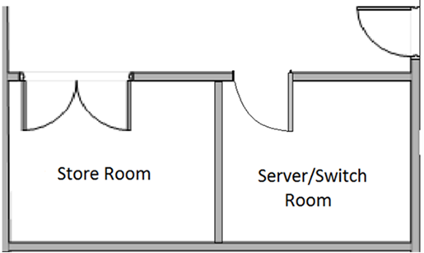The server/switch room, formally the store room, currently has double doors and is open to all Ace Training LTD employees. The proposed security solution is to split the store room in half, with a stud wall, keeping the double doors for the store room and creating a new door for the server/switch room (figure 7). Also, for additional security, the suspended ceiling in the new server room will be replaced with a standard solid ceiling, thus, preventing intrusion from above.

3.5m

Figure - New Store and Server/Switch Room Layout

3m

#### 9.3.1.1 Server room wall and Ceiling

The server room wall will be approximately 3m x 2.4m x 100mm and will be constructed using Gyprock Gypframe C Stud and Gypframe Floor and Ceiling Channel. Gyprock 12.5mm plaster board will be used as cladding with a Knauf 70mm glass fibre insulation core. (see figure 8)

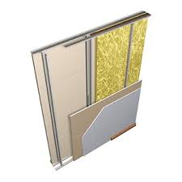The server room ceiling will be approximately 3.5mx3m and will be constructed using Gypframe Floor and Ceiling Channel, cladded with Gyprock 9.5mm plasterboard and insulated using Knauf 75mm Drytherm 35 slab insulation. (See Figure 9)

Figure - Server/Switch Room Wall Construction

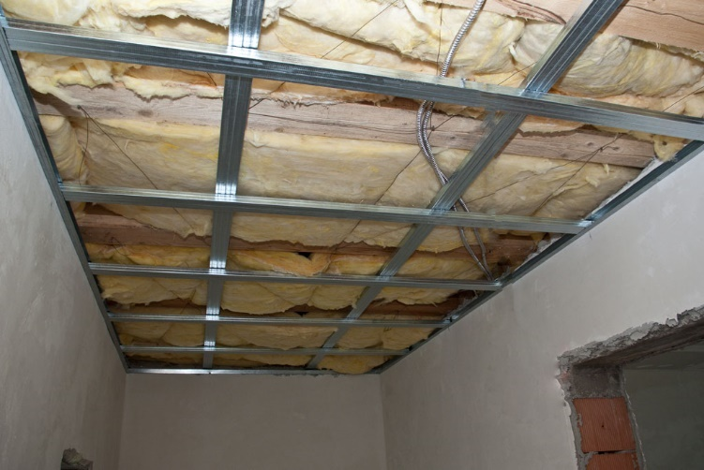

Figure - Server/Switch Room Ceiling Construction

Gypframe is a modern, engineered alternative to traditional timber frame and blockwork construction. The Gypframe-based wall, ceiling and floor system was chosen over traditional methods as it is quicker and easier to install while meeting the highest performance requirements. Also, they are up to 50% lighter than equivalent timber systems, and up to 70% lighter than blockwork, are easier to transport and offer a high strength to weight ratio for guaranteed performance and long life. Furthermore, Gypframe components are easy to cut on site, non-flammable and will not rot, twist or warp.

Knauf 75mm Drytherm 35 slab insulation will be used to insulate the server/switch room. DriTherm Cavity Slabs are rigid slabs of non-combustible, water repellent, glass mineral wool. They are 455mm wide to suit standard vertical wall tie spacings, ensuring a closed joint with adjacent slabs. DriTherm Cavity Slabs are for the thermal insulation of cavities of either internal or external walls and are installed to fill the cavity fully.

Insulating the server/switch room will enable, in conjunction with an air conditioning unit, Ace Training LTD to regulate the temperature within the room and, thus, helping to prevent overheating of the servers and other sensitive equipment stored within.

|  |  |  |
| --- | --- | --- |
| Installation Schedule | | |
| Task | **Completion** |
| Wall and ceiling frame | 1 day |
| Boarding | 1 day |
| Plastering and drying time | 3 days |
| Skirting boards | 0.25 day |
| Painting and drying time | 1 day |
| Total Time | **6.25 days** |

|  |  |  |  |  |  |
| --- | --- | --- | --- | --- | --- |
| Pricing | |  |  |  | |
| Product code | Description | Quantity | Price Each | Price total | |
| 1120PRO040 | Metal 70mm C Stud 0.5mm x 2.4mt | 7 | 2.81 | 19.60 | |
| 1120PRO240 | Metal 72mm Track (30mm Leg) 0.5mm x3mtr | 6 | 3.10 | 18.60 | |
| 1120PRO070 | Metal 70mm C Stud 0.5mm x 3.6mt | 7 | 4.20 | 29.40 | |
| 2802PLA050 | Taper Edge Plasterboard 2400 x 1200x 12.5mm | 5 | 4.40 | 22.00 | |
| 2802PLA020 | Taper Edge Plasterboard 1800 x 900 x 9.5mm | 7 | 3.54 | 24.78 | |
| 4202INS003 | 75mm Dritherm 37 Cavity Slab Insulation 4.37m2 Pack | 4 | 10.85 | 43.40 | |
| 6010DRY007 | Wafer Head Jack Point Screws 13mm Box | 1 |  | 13.18 | |
| 6010DRY030 | Black Drywall Screws 42mm x 3.5mm x Box | 1 |  | 7.47 | |
| 2901TAP010 | Fibre Scrim Plasterboard Tape 48mm x 90M | 1 |  | 3.95 | |
| 2801PLA050 | Thistle Board Finish 25Kg Bag | 4 | 4.47 | 17.18 | |
| 8999MDF072 | MDF 18mm X 119mm Torus 1 White Primed | 6m | 1.25 | 7.50 | |
| 5709PAI100D | Armstead Trade Contract Matt White 10Ltr | 1 |  | 16.95 | |
| 5709LEY040 | Leyland High Gloss Brilliant White 750Mls | 1 |  | 5.75 | |
| 5709LEY078 | Leyland Undercoat White 750ml | 1 |  | 5.72 | |
| Beesley and Fildes LTD Quote n 25985520 | | | Materials Total | | 283.40 | |
| nufix Home Improvments LTD Quote no 13724 | | | Labour | | 500.00 | |
|  | | | Total Cost | | 783.40 +VAT | |

#### 9.3.1.2 Security Door and Lock

The server room will be secured using a K1050 Steel Security Personnel Door (Figure 10) and a Codelock 2210 medium duty electronic lock.

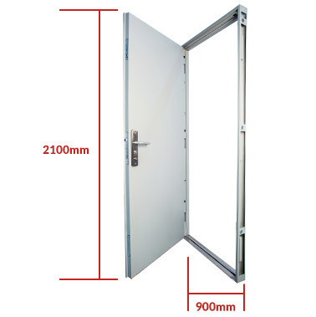

Figure - High Security Door

|  |  |
| --- | --- |
| Security Door Specifications | |
| Door Height | 2100mm |
| Door Width | 900mm |
| Opening | Left-hand opening |
| Finish | Grey Primer |
| Frame Type | Easy fit adjustable |
| Outer Skin | 1.2mm Zinc Coated Steel folded 45mm thick |
| Internal Structure | Dufaylite honeycomb core |
| Additional Security | Integral anti-jemmy strip |

The CL2210 electronic codelock is a medium duty electronic lock. The outside knob turns freely without operating the latch bolt. Only when a valid code is entered, the blue LED lights burn and the knob will retract the latch bolt. The key will open the door for management functions and in the event of power loss. The lock can store up to 80 different User Codes which can be 4, 5 or 6 digits long. Programming is via the keypad, using the Master Code.

|  |  |
| --- | --- |
| **Code Lock Specifications** | |
| **Body Material** | Zinc Alloy |
| **Buttons** | Individual, stainless steel |
| **Code free option** | Yes |
| **Door thickness** | 35mm - 60mm (1 3/8" - 2 3/8") |
| **Finish** | Brushed steel, polished brass |
| **Key override** | Yes |
| **Non-handed** | Lock will fit doors hung on the left or right |
| **Power** | 2 x 1.5v AA cells |
| **Spindle type** | Flat bar spindle & 8mm square adaptor |
| **Suitable for** | Internal and external use |
| **Type** | Mortice deadbolt |

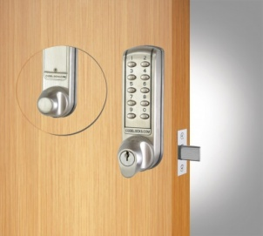

Figure - Code Lock

|  |  |  |  |  |
| --- | --- | --- | --- | --- |
| Pricing | |  |  |  |
| Product code | **Description** | **Quantity** | **Price Each** | **Price total** |
| K105 | High Security Door | 1 | 324.00 | 324.00 |
| CL2210 | Electronic Mortice Deadbolt | 1 | 107.80 | 107.80 |
| Supplier: Kenfield and Codelocks | | | Materials Total | 431.80 |
| nufix doors LTD Quote no 13724 | | | Labour | 150 +VAT |
|  | | | Total Cost | 581.80 |

|  |  |  |
| --- | --- | --- |
| Installation Schedule | | |
| Task | **Completion** |
| Door Opening | 0.25 day |
| Fitting Door and Frame | 0.5 day |
| Fitting Codelock | 0.25 Day |
| Total Time | **1 Day** |

### 9.3.2 CCTV

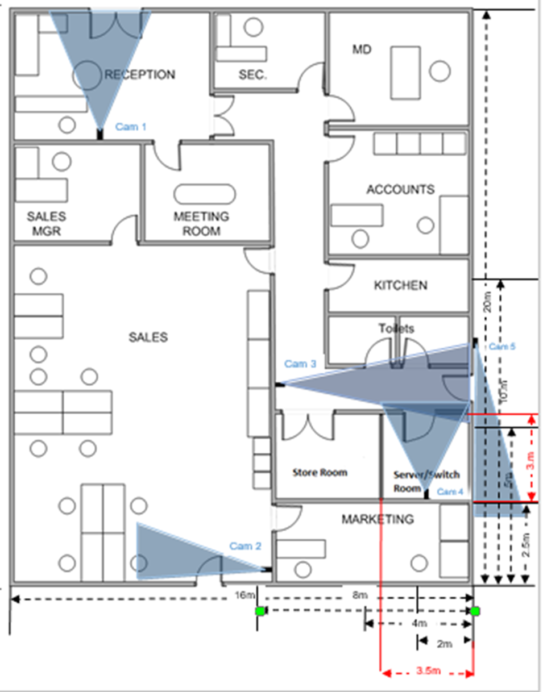For additional security, a CCTV system will be installed. There will be CCTV cameras installed internally at each entrance to the building, a further two cameras covering the server room corridor and inside the server/switch room. Installed external covering the rear entrance (See Figure 12).

Monitor and DVR

Figure - CCTV System Layout and Wiring Diagram

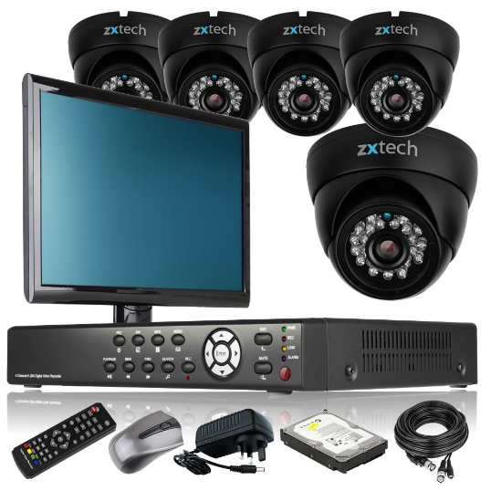The CCTV system, from Domar, is a complete out of the box CCTV solution. The system contains a Zxtech 8 channel HD DVR with a 1TB hard drive, five internal/external Sony Effio-e infrared day & night colour CCTV cameras, and an HD monitor.

Also included in the package is 3 x 10m and 2 x 20m CCTV cable and power splitters.

|  |  |
| --- | --- |
| **DVR Specifications** | |
| **Operating System** | Embedded LINUX |
| **Video Compression** | 960H/D1 / Half-D1 / CIF |
| **Display Frame Rate** | PAL:960H@16fps  D1@25fps; NTSC:960H@20fps D1@30fps,Bit Rate: 128 to 2048 kbps |
| **Audio Compression** | ADPCM |
| **Bit Rate** | 16 kbps |
| **Voice Talkback** | Two-way Talkback |
| **Interface** | 1 CH SATA |
| **Capacity** | 1TB |
| **Recording Mode** | Schedule, Manual, Alarm, Motion Detection |
| **Multi - Playback** | 1/4/all simultaneously |
| **Digital Zoom** | Live view zoom, playback zoom |
| **Web Browser** | Support Windows platform IE6 to IE10, Chrome, Firefox, Opera, Safari |
| **Client Software** | Support Windows and MAC OS platform |
| **Mobile Device** | Support iPhone, iPad, Android, live view & playback |
| **Video Input** | 8 CH,  BNC(1.0Vp-p, 75Ω) |
| **Video Output** | 1 CH, BNC (1.0Vp-p, 75Ω); 1 CH, VGA (1280 x 1024, 1024 x 768, 800 x 600); 1 CH,HDMI 1920 x1080 |
| **Audio Input** | 8CH |
| **Audio Output** | 1CH |
| **Network Port** | 1 CH, RJ45 10/100M Ethernet interface |
| **Power Supply** | DC 12V/3A |
| **Consumption** | <10W (without HDD) |
| **Environment** | -10° to 60°, 10%£ to 90%RH |
| **Dimension** | 274(w)X215(d)X45(h)mm (Small 1U) |

|  |  |
| --- | --- |
| **Camera Specifications** | |
| **Pick Up Element** | 700TVL 1/3' Effio-e |
| **Effective Picture Element** | (H*V) NTSC:976(H)x494(V) PAL:976(H)x582(V) |
| **Horizontal Resolution** | 700 TV Line |
| **S/N Ratio** | >50dB |
| **Auto Electronic Shutter** | 1/50-1/100,000s(PAL) 1/60-1/100,000s(NTSC) |
| **Scanning system:** | 2:1 Interface |
| **Minimum Illumination** | 0,001 Lux; 0 Lux with IR on |
| **Gamma Adjusting** | 0.45 |
| **IR Project Distance** | 20 Meter, 65 Feet, 24 x Infrared LED |
| **IR Status** | Under 10 Lux by CDS |
| **IR Power On** | CDS AUTO Control |
| **Video Output** | Composite Signal (1.0Vpp, 75ohm;) |
| **Auto Gain Control** | Auto |
| **Power/Current** | 12VDC (+/-10%) 550mA |
| **Lens** | Broad Lens 3.6mm.F2.0 |
| **Dimension(mm)** | 110(W)x110(H)x85(D) |

**Figure 7 CCTV System**

|  |  |
| --- | --- |
| Installation Schedule | |
| Task | **Completion** |
| Camera installation | **1 day** |
| Wiring | **1 day** |
| Set up | **0.5 day** |
| Total Time | **2.5 days** |

|  |  |  |  |  |
| --- | --- | --- | --- | --- |
| Pricing | |  |  |  |
| Product code | Description | Quantity | Price Each | Price total |
| CC1625SON | 5-x-outdoor-black-700tvl-and-8-channel-classic-complete-cctv-system | 1 | 314.75 | 314.75 +VAT |
| Supplier: Domar | | | Materials Total | 314.75 +VAT |
| nufix Home Improvments Quote no 13724 | | | Labour | 250.00 +VAT |
|  | | | Total Cost | 564.75 +VAT |

### 9.3.3 Client PCs

As stated, the easiest way to secure mission critical equipment such as PCs would be to lock them away in a secure location. In this case, however, locking the equipment away would be impractical and time-consuming. With this in mind, the decision was made to secure the PCs and other equipment, such as printers, in place using a cable lock system (Figure 13).

All Kensington locks are built to exacting engineering standards. This lock is rated as Safe SafeLocks engineered and tested to Kensington's exacti…Pro, a rating awarded to Kensington Security Locks that are tested under stringent test conditions by third party testing agencies for their ability to withstand attacks.

The locks are provided with two keys for each standard lock. The keys are stamped with a unique code enabling the user to request a new key from Kensington if lost. Kensington locks are made with high-carbon steel cables and tested under real-world conditions to resist lock-picking, corrosion, tampering and extreme environments.

Figure - Kensington Security Lock

|  |  |
| --- | --- |
| Kensington PC lock Specification | |
| Cable Diameter | 5.3mm |
| Cable Length | 2.4m |
| Colour | Silver |
| Material | Steel |

|  |  |
| --- | --- |
| Installation Schedule | |
| Task | **Completion** |
| Installation 20 x PC | 1 Day |
| Total Time | **1 Day** |

|  |  |  |  |  |
| --- | --- | --- | --- | --- |
| Pricing | |  |  |  |
| Product code | Description | Quantity | Price Each | Price total |
| K64615EU | Kensington Desktop PC &amp; Peripherals Lock Kit | 20 | 20.69 | £413.80 +VAT |
| Supplier: NetStore Direct | | | Materials Total | £413.80 +VAT |
| nufix Home Improvements Quote no 13724 | | | Labour | £150.00 +VAT |
|  | | | Total Cost | £563.80 +VAT |

### 9.3.4 Total Physical Security Cost and Installation Schedule

|  |  |
| --- | --- |
| Installation Schedule | |
| Task | **Completion** |
| Server/Switch Room | **6.25 Days** |
| Security Door and lock | **1 Day** |
| CCTV | **2.5 Days** |
| Kensington Locks | **1 day** |
| Total Time | **10.75 Days** |

Total Cost

|  |  |
| --- | --- |
| Description | Price |
| Server/Switch Room | £783.40 +VAT |
| Security Door and Lock | £581.80 +VAT |
| CCTV | £564.75 +VAT |
| Kensington PC Locks | £563.80 +VAT |
| **Total Cost** | **£2493.75 +VAT** |